

**Capstone Project Report**

**Report 3 – Software Requirement Specification**

– Ho Chi Minh City, 01/2021 –

**Table of Contents**

I. Project Report 6

1. Status Report 6

2. Team Involvements 6

3. Issues/Suggestions 6

II. Software Requirement Specification 7

1. Overall Description 7

1.1 Product Overview 7

1.2 Business Rules 7

2. User Requirements 11

2.1 Overview 11

2.2 <<Unauthorized User>> Overview Use Case 14

2.3 <<Authorized User>> Overview Use Case 18

2.4 <<Administrator>> Overview Use Case 23

2.5 <<Salesman>> Overview Use Case 39

2.6 <<Sales Supervisor>> Overview Use Case 69

2.7 <<Sales Manager>> Overview Use Case 77

2.8 <<System Handler>> Overview Use Case 78

2.9 <<Firebase>> Overview Use Case 79

3. Functional Requirements 81

3.1 System Functional Overview 81

4. Non-Functional Requirements 85

4.1 External Interfaces 85

4.2 Quality Attributes 86

5. Other Requirements 86

5.1 Appendix1 - Messages List 86

**List Tables**

*Table 1. Business Rules* 9

*Table 2. System Actors* 12

*Table 3. Use Cases List* 14

*Table 4. <<Unauthorized User>> Login* 16

*Table 5. <<Unauthorized User>> Forget password* 17

*Table 6. <<Authorized User>> View profile* 19

*Table 7. <<Authorized User>> Edit profile* 20

*Table 8. <<Authorized User>> Change avatar* 22

*Table 9. <<Authorized User>> Logout* 22

*Table 10. <<Authorized User>> View notifications* 23

*Table 11. <<Administrator>> Create new accounts* 26

*Table 12. <<Administrator>> Search accounts* 27

*Table 13. <<Administrator>> View list of accounts* 28

*Table 14. <<Administrator>> View account’s details* 29

*Table 15. <<Administrator>> Edit account’s information* 31

*Table 16. <<Administrator>> Create new schools* 34

*Table 17. <<Administrator>> Search schools* 35

*Table 18. <<Administrator>> View list of schools* 36

*Table 19. <<Administrator>> View school’s details* 37

*Table 20. <<Administrator>> Edit school’s information* 38

*Table 21. <<Salesman>> Search target schools* 41

*Table 22. <<Salesman>> View list of target schools* 42

*Table 23. <<Salesman>> View target school’s details* 44

*Table 24. <<Salesman>> Edit school’s information* 46

*Table 25. <<Salesman>> Create memorandums* 47

*Table 26. <<Salesman>> View my memorandums* 48

*Table 27. <<Salesman>> View memorandum’s details* 49

*Table 28. <<Salesman>> Edit my memorandums* 50

*Table 29. <<Salesman>> Create reports* 52

*Table 30. <<Salesman>> Search reports* 54

*Table 31. <<Salesman>> View all reports* 55

*Table 32. <<Salesman>> View report’s details* 56

*Table 33. <<Salesman>> Edit reports* 58

*Table 34 <<Salesman>> Remove reports* 59

*Table 35. <<Salesman>> Create personal activities* 61

*Table 36. <<Salesman>> Search other’s workplan* 62

*Table 37. <<Salesman>> View workplan* 63

*Table 38. <<Salesman>> View personal activity’s details* 64

*Table 39. <<Salesman>> Edit personal activities* 67

*Table 40. <<Salesman>> Remove personal activities* 68

*Table 41. <<Sales Supervisor>> Create target schools* 71

*Table 42. <<Sales Supervisor>> Edit target schools* 72

*Table 43. <<Sales Supervisor>> Assign salesmen to target schools* 74

*Table 44. <<Sales Supervisor>> Remove target schools* 75

*Table 45. <<Sales Supervisor>> Comment on Salesmen’s reports* 77

*Table 46. <<Sales Manager>> View all memorandums* 78

*Table 47. << System Handler>> Send emails* 79

*Table 48. << Firebase>> Send notifications* 80

*Table 49. Screen Details* 82

*Table 50. Screen Authorization* 83

*Table 51. Non-Screen Functions* 83

*Table 52. Entities List* 85

*Table 53. Appendix1 - Messages List* 87

**List Figures**

*Figure 1. System Context Diagram* 7

*Figure 2. Use case Overview* 11

*Figure 3. <<Unauthorized User>> Overview Use Case* 14

*Figure 4. <<Unauthorized User>> Login* 15

*Figure 5. <<Unauthorized User>> Forget password* 16

*Figure 6. <<Authorized User>> Overview Use Case* 18

*Figure 7. <<Authorized User>> View profile* 18

*Figure 8. <<Authorized User>> Edit profile* 19

*Figure 9. <<Authorized User>> Change avatar* 21

*Figure 10. <<Authorized User>> Logout* 22

*Figure 11. <<Authorized User>> View notifications* 22

*Figure 12. <<Administrator>> Overview Use Case* 24

*Figure 13. <<Administrator>> Create new accounts* 24

*Figure 14. <<Administrator>> Search accounts* 26

*Figure 15. <<Administrator>> View list of accounts* 27

*Figure 16. <<Administrator>> View account’s details* 28

*Figure 17. <<Administrator>> Edit account’s information* 29

*Figure 18. <<Administrator>> Create new schools* 31

*Figure 19. <<Administrator>> Search schools* 34

*Figure 20. <<Administrator>> View list of schools* 35

*Figure 21. <<Administrator>> View school’s details* 36

*Figure 22. <<Administrator>> Edit school’s information* 37

*Figure 23. <<Salesman>> Overview Use Case* 39

*Figure 24. <<Salesman>> Search target schools* 39

*Figure 25. <<Salesman>> View list of target schools* 41

*Figure 26. <<Salesman>> View target school’s details* 42

*Figure 27. <<Salesman>> Edit school’s information* 44

*Figure 28 <<Salesman>> Create memorandums* 46

*Figure 29. <<Salesman>> View my memorandums* 47

*Figure 30. <<Salesman>> View memorandum’s details* 48

*Figure 31. <<Salesman>> Edit my memorandums* 49

*Figure 32. <<Salesman>> Create reports* 51

*Figure 33. <<Salesman>> Search reports* 52

*Figure 34. <<Salesman>> View all reports* 54

*Figure 35. <<Salesman>> View report’s details* 55

*Figure 36. <<Salesman>> Edit reports* 56

*Figure 37. <<Salesman>> Remove reports* 58

*Figure 38. <<Salesman>> Create personal activities* 59

*Figure 39. <<Salesman>> Search other’s workplan* 61

*Figure 40. <<Salesman>> View workplan* 62

*Figure 41. <<Salesman>> View personal activity’s details* 63

*Figure 42. <<Salesman>> Edit personal activities* 65

*Figure 43. <<Salesman>> Remove personal activities* 67

*Figure 44. <<Sales Supervisor>> Overview Use Case* 69

*Figure 45. <<Sales Supervisor>> Create target schools* 69

*Figure 46. <<Sales Supervisor>> Edit target schools* 71

*Figure 47. <<Sales Supervisor>> Assign salesmen to target schools* 72

*Figure 48. <<Sales Supervisor>> Remove target schools* 74

*Figure 49. <<Sales Supervisor>> Comment on Salesmen’s reports* 75

*Figure 50. <<Sales Manager>> Overview Use Case* 77

*Figure 51. <<Sales Manager>> View all memorandums* 77

*Figure 52. <<Sales Manager>> Overview Use Case* 78

*Figure 53. <<System Handler>> Send emails* 78

*Figure 54. <<Firebase>> Overview Use Case* 79

*Figure 55. << Firebase>> Send notifications* 80

*Figure 56. Screen Flow* 81

*Figure 57. Entity Relationship Diagram* 84

# I. Project Report

## 1. Status Report

|  |  |  |  |
| --- | --- | --- | --- |
| **#** | **Work Item** | **Status** | **Notes (Work Item in Details)** |
| 1 |  | Pending |  |
| 2 |  | In Progress |  |
| 3 |  | Completed |  |

## 2. Team Involvements

|  |  |  |  |
| --- | --- | --- | --- |
| **#** | **Task** | **Member** | **Notes (Task Details, etc.)** |
| 1 |  | HaPTN |  |
| 2 |  | NguyenLG |  |
| 3 |  | GiaNH |  |
| 4 |  | ~~PhuVT~~ | Dropped since January 28th, 2021 |

## 3. Issues/Suggestions

|  |  |  |  |
| --- | --- | --- | --- |
| **#** | **Issue** | **Status** | **Notes (Solution, Suggestion, etc.)** |
| 1 |  | Pending |  |
| 2 |  | In Progress |  |
| 3 |  | Completed |  |

# II. Software Requirement Specification

## 1. Overall Description

### 1.1 Product Overview

The Sales Management System for Major Education is a new software system that replaces the current manual working processes of the Sales Department of Major Education.

The working processes includes managing target schools and their related materials (daily reports, memorandums / MOUs – *Memorandum of understanding*), collecting daily reports, and planning work-plan.

The system context diagram below demonstrates the human components (actors) that interacted with SMSME for release 1.0.

The SMSME is expected to automate the existing manual workflow of Major Education and increase the working productivity of Major’s staffs by giving motivation between them.

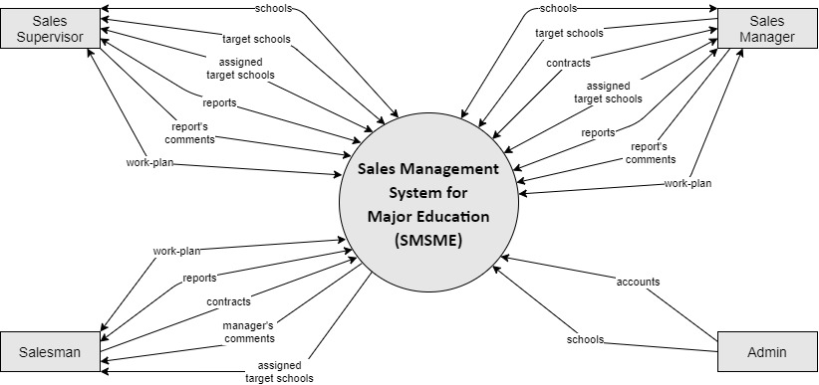

*Figure 1. System Context Diagram*

### 1.2 Business Rules

|  |  |
| --- | --- |
| **ID** | **Rule Definition** |
| BR-01 | This system is only used for Sales Department of the Major Education.  Public users shall not use this system. |
| BR-02 | Users shall not register an account. Only Administrators (Admin) can create new accounts for users. |
| BR-03 | Users shall reset their forgotten password.  When users send request to reset their forgotten password, the system automatically generates a verification code and sends that code to user’s email. |
| BR-04 | Admin shall create new accounts for users but not including the password.  Password is automatically generated by the system and sent to user’s email. |
| BR-05 | Users (all roles) can view and edit their profile, including email, phone number, address, avatar and password.  Users shall not edit username, full name, birthday, gender and working status (“active”/ “inactive”) (also shall not view “working status”). |
| BR-06 | When an employee quits his/her job or moves to another department, Admin shall changes his/her “working status” from “active” to “inactive”. |
| BR-07 | Users whose “working status” is “inactive” shall not log into the system. |
| BR-08 | Admin shall edit user’s phone number, gender, birthday, roles, and working status.  Admin shall not edit username and email of the existed accounts. |
| BR-09 | Admin manage the raw data of all accounts and schools in the system.  Admin shall not create or edit fields related to business process of the sales. |
| BR-10 | Only Admin shall create new schools.  Sales Managers and Sales Supervisors can view list of all schools and their details but shall not create. |
| BR-11 | Sales Managers and Sales Supervisors shall create lists of target schools.  The initial list of target schools has not had PIC yet.  The initial list of target schools is required to have purpose. |
| BR-12 | Sales Managers and Sales Supervisors can modify (create, remove, edit or assign) lists of target schools. |
| BR-13 | Sales Managers and Sales Supervisors shall not modify (create, remove, edit or assign) lists of target schools in the past. |
| BR-14 | Sales Managers and Sales Supervisors shall assign or unassigned Salesmen to target schools.  The assigned person is called “PIC” (person in charge). |
| BR-15 | Each target school shall be assigned to only one PIC at a time.  A target school can be assigned many times to different PIC. |
| BR-16 | An assigned target school can be unassigned. |
| BR-17 | If Sales Managers want to change the PIC of a target school, they need to unassign the current PIC first before assigning a new PIC. |
| BR-18 | Sales Managers and Sales Supervisors shall not remove target schools which have been assigning or having reports or being in the memorandum’s duration. |
| BR-19 | Only Sales Managers and Sales Supervisors can view list of all target schools.  Salesmen can only view list of their own assigned schools. |
| BR-20 | Business trips to each target school have different purposes, depends on the school status (for example: “Leads”, “Customer”, “Ngưng hợp tác”). |
| BR-21 | Salesmen shall visit their assigned schools. After every business trip to the target schools, Salesmen shall submit a daily report. |
| BR-22 | Salesmen shall successfully meet school’s representatives (principals) of at least 3 new target schools every working day. |
| BR-23 | Salesmen shall not create reports for a date in the past or the future.  The reported date is the current date. |
| BR-24 | List of all reports is shared, so any Salesmen, Sales Managers or Sales Supervisors can view it. |
| BR-25 | Sales Managers and Sales Supervisors can comment on other Salesmen’s, Sales Supervisors’ or Sales Managers’ reports, and shall not comment on their own reports. |
| BR-26 | When Sales Managers comment on reports, notifications shall be sent to the corresponding users. |
| BR-27 | Sales Managers and Sales Supervisors shall only edit or remove comments in the current school year. |
| BR-28 | The users can only edit or remove their own reports and in the current school year. |
| BR-29 | The users shall not edit or remove the reports which were commented. |
| BR-30 | After a business trip to the target schools, if the users collect some information that is different from the existed school’s details, the users can only edit data related to the school’s representative. The other school’s data, user needs to inform to the Admin to edit them. |
| BR-31 | A target school may has one or multiple memorandum’s memorandums (in this project, we state it as “memorandums” for short), which is like a personal memorandum copied from the paper memorandums between Major Education and their target schools.  The real memorandums are stored by the Accounting Department.  \**Note*:  In the context of the Major Education, the word “memorandum” refers to “MOU (Memorandum of understanding)[1]” between the Major Education and their target shools. |
| BR-32 | The PIC shall only create, edit and view the memorandums (MOUs) of their assigned schools. |
| BR-33 | When PIC create new memorandums, notifications shall be sent to the Sales Managers. |
| BR-34 | Only Sales Managers shall view all memorandums of all target schools in the list.  However, Sales Managers shall not edit the memorandums (MOUs) of schools which they are not in charge of. |
| BR-35 | Each Salesman, Sales Manager and Sales Supervisor has his/her own work-plan.  Salesmen can search to view work-plan of other Salesmen but shall not view work-plan of Sales Sales Supervisors or Sales Managers.  Sales Manager and Sales Supervisor can view work-plan of all users.  An item in work-plan is called “personal activity”. |
| BR-36 | The users shall not modify (create, edit or remove personal activities) work-plan of the others. |
| BR-37 | A personal activity has three statuses: “pending” (not started yet or in progress), “completed” and “failed”.  When the users create a personal activity, the default status shall be “pending”. |
| BR-38 | Any personal activity has endtime.  When the current time reaches endtime, if users have not marked that personal activity as completed, the default status shall be changed into “failed”; otherwise, the status shall be “completed”. |
| BR-39 | Sales Managers and Sales Supervisors supervise Salesmen via daily reports and work-plan. |
| BR-40 | If a user plays two or more roles at the same time, they need to have multiple accounts, each account only for a sole role.  For example:  Ms. Tuyen in Major plays two roles: Admin and Salesman; Mr. Tien in Major plays two roles: Sales Supervisor and Salesman. |

*Table 1. Business Rules*

## 2. User Requirements

### 2.1 Overview

#### Use Case Diagram

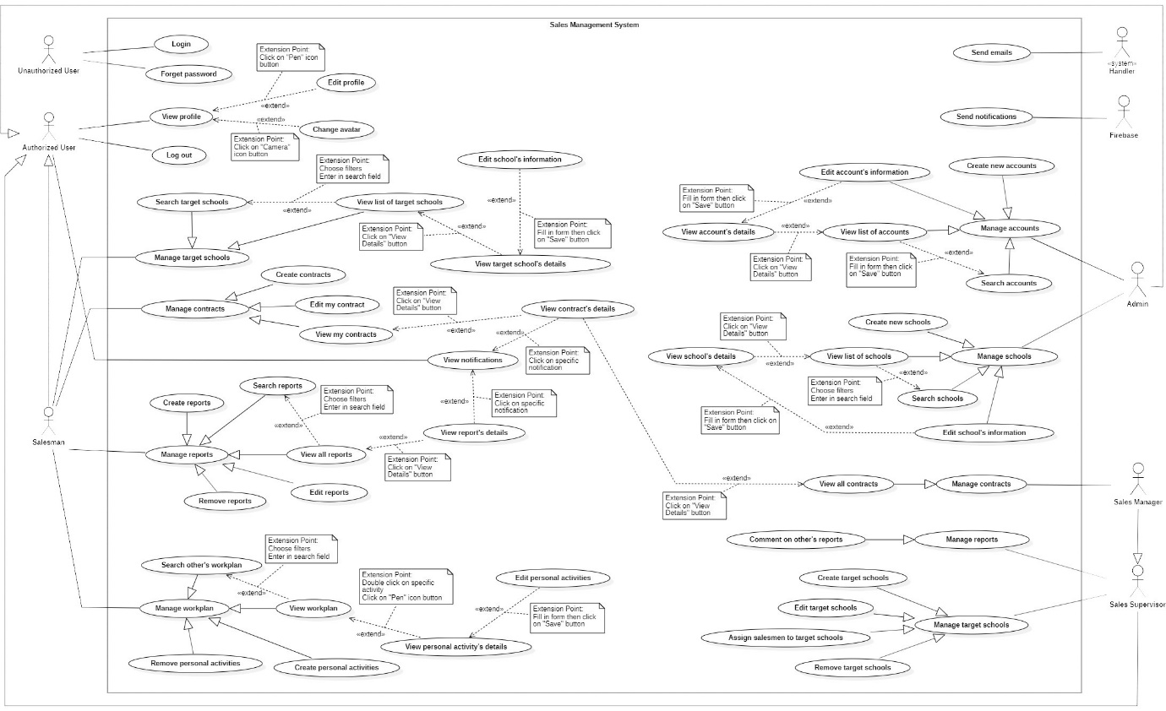

*Figure 2. Use case Overview*

#### System Actors

|  |  |  |
| --- | --- | --- |
| **#** | **Actor** | **Description** |
| 1 | Unauthorized User | The people who have not logged into the system yet. |
| 2 | Authorized User | The people who have logged into the system with the account (Administrator, Salesman, Sales Manager).  All functions of this user are general functions that a normal user can do without considering the role. |
| 3 | Administrator | The Administrators manage data of all accounts and all schools in the system. |
| 4 | Salesman | * The Salesmen have business trips to target schools for many purposes, such as introducing and selling Major Education’s programs to target schools for cooperation. * Salesmen shall create memorandum and view his/her own assigned target schools’ memorandums. |
| 5 | Sales Supervisor | * Sales Supervisor manages target schools and supervises salesmen’s reports and work-plans. * Sales Supervisor is not allow to view memorandums of others’. |
| 6 | Sales Manager | * Sales Manager manages target schools and supervises salesmen’s reports and work-plans. * Sales Manager shall view all memorandums of all Salesmen. |
| 7 | <<system>> Handler | The system which handles the automatic processes and operations. |
| 8 | Firebase | The third-party service which stores and send the notifications. |

*Table 2. System Actors*

#### Use Cases List

|  |  |  |  |
| --- | --- | --- | --- |
| **ID** | **Use Case** | **Primary Actors** | **Secondary Actors** |
| UC-01 | Login | Unauthorized User |  |
| UC-02 | Forget password | Unauthorized User |  |
| UC-03 | View Profile | Authorized User,  Salesman,  Sales Supervisor,  Sales Manager,  Administrator |  |
| UC-04 | Edit Profile | Authorized User,  Salesman,  Sales Supervisor,  Sales Manager,  Administrator |  |
| UC-05 | Change avatar | Authorized User,  Salesman,  Sales Supervisor,  Sales Manager,  Administrator |  |
| UC-06 | Log out | Authorized User,  Salesman,  Sales Supervisor,  Sales Manager,  Administrator |  |
| UC-07 | View notifications | Authorized User,  Salesman,  Sales Supervisor,  Sales Manager,  Administrator |  |
|  | ***Manage accounts*** | | |
| UC-08 | Create new accounts | Administrator |  |
| UC-09 | Search accounts | Administrator |  |
| UC-10 | View list of accounts | Administrator |  |
| UC-11 | View account’s details | Administrator |  |
| UC-12 | Edit account’s information | Administrator |  |
|  | ***Manage schools*** | | |
| UC-13 | Create new schools | Administrator |  |
| UC-14 | Search schools | Administrator |  |
| UC-15 | View list of schools | Administrator |  |
| UC-16 | View school’s details | Administrator |  |
| UC-17 | Edit school’s information | Administrator |  |
|  | ***Manage target schools*** |  |  |
| UC-18 | Search targetschools | Salesman,  Sales Supervisor,  Sales Manager |  |
| UC-19 | View list of targetschools | Salesman,  Sales Supervisor,  Sales Manager |  |
| UC-20 | View targetschool’s details | Salesman,  Sales Supervisor,  Sales Manager |  |
| UC-21 | Edit school’s information | Salesman,  Sales Supervisor,  Sales Manager |  |
|  | ***Manage memorandums*** | | |
| UC-22 | Create memorandums | Salesman |  |
| UC-23 | View my memorandums | Salesman |  |
| UC-24 | View memorandum’s details | Salesman |  |
| UC-25 | Edit my memorandums | Salesman |  |
|  | ***Manage reports*** | | |
| UC-26 | Create reports | Salesman |  |
| UC-27 | Search reports | Salesman |  |
| UC-28 | View all reports | Salesman |  |
| UC-29 | View report’s details | Salesman |  |
| UC-30 | Edit reports | Salesman |  |
| UC-31 | Remove reports | Salesman |  |
|  | ***Manage workplan*** | | |
| UC-32 | Create personal activities | Salesman,  Sales Supervisor,  Sales Manager |  |
| UC-33 | Search other’s workplan | Salesman,  Sales Supervisor,  Sales Manager |  |
| UC-34 | View workplan | Salesman,  Sales Supervisor,  Sales Manager |  |
| UC-35 | View personal activity's details | Salesman,  Sales Supervisor,  Sales Manager |  |
| UC-36 | Edit personal activities | Salesman,  Sales Supervisor,  Sales Manager |  |
| UC-37 | Remove personal actitivities | Salesman,  Sales Supervisor,  Sales Manager |  |
|  | ***Manage target schools*** | | |
| UC-38 | Create target schools | Sales Supervisor,  Sales Manager |  |
| UC-39 | Edit target schools | Sales Supervisor,  Sales Manager |  |
| UC-40 | Assign salesmen to target schools | Sales Supervisor,  Sales Manager |  |
| UC-41 | Remove target schools | Sales Supervisor,  Sales Manager |  |
|  | ***Manage reports*** | | |
| UC-42 | Comment on salesmen's reports | Sales Supervisor,  Sales Manager |  |
|  | ***Manage Memorandums*** | | |
| UC-43 | View all memorandums | Sales Manager |  |

*Table 3. Use Cases List*

### 2.2 <<Unauthorized User>> Overview Use Case

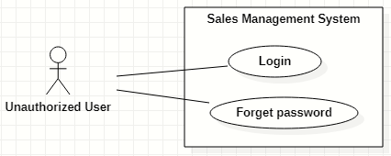

*Figure 3. <<Unauthorized User>> Overview Use Case*

#### Login

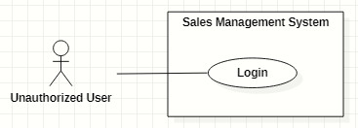

*Figure 4. <<Unauthorized User>> Login*

|  |  |  |  |  |  |
| --- | --- | --- | --- | --- | --- |
| ID and Name: | **UC-01 Login** | | | | |
| Created By: | GiaNH | | Date Created: | 05/02/2021 |
| Primary Actor: | Unauthorized User | | Secondary Actors: | N/A |
| Description: | This use case allows the user to log into the system to use the services of the system. | | | | |
| Trigger: | The user clicks on the “Login” button on the Login screen. | | | | |
| Preconditions: | PRE-1. The user has to own an account with a username and password.  PRE-2. The user has not logged into the system yet. | | | | |
| Post-conditions: | POST-1. The user successfully logs into the system, and be redirected to the Home screen. | | | | |
| Normal Flow: | **Step** | **Actor Action** | | **System Response** | |
| 1 | The user opens the login view in web browsers. | | The system requires identifying information from the user:   * “Username”: text input, required. * “Password”: text input, required. | |
| 2 | The user inputs into the “username” and “password” fields on Login form. | | [Exception 1] | |
| 3 | The user clicks on “Login” button. | | The system allows the user to access into and redirects to the corresponding Home screen (based on the role of user).  [Exception 2]  [Exception 3] | |
| Alternative Flows: | N/A | | | | |
| Exceptions: | **No** | **Cause** | | **System Response** | |
| 1 | The user inputs invalid format content into the “username” and “password” fields. | | The system shows the error message: “Invalid username or password”. | |
| 2 | The user inputs the wrong username or password. | | The system shows the error message: “Wrong username or password”. | |
| 3 | The user’s device does not connect to the Internet or the server has internal error. | | The system shows the error message: “Connection Failed or Internal Error”. | |
| Priority: | Normal | | | | |
| Frequency of Use: | Usually | | | | |
| Business Rules: | * BR-01, BR-07 * The required information are username, password. * The username must be 8 – 30 characters length and must not include special characters. * The password must be 8 – 30 characters length and must be hashed encrypted. | | | | |
| Other Information: | N/A | | | | |
| Assumptions: | N/A | | | | |

*Table 4. <<Unauthorized User>> Login*

#### Forget password

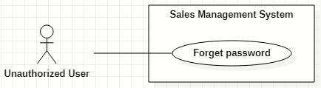

*Figure 5. <<Unauthorized User>> Forget password*

|  |  |  |  |  |  |
| --- | --- | --- | --- | --- | --- |
| ID and Name: | **UC-02 Forget password** | | | | |
| Created By: | HaPTN | | Date Created: | 12/04/2021 |
| Primary Actor: | Unauthorized User | | Secondary Actors: | N/A |
| Description: | This use case allows the user to reset their forgotten password. | | | | |
| Trigger: | The user clicks on “Forgot password?” link on the Login screen. | | | | |
| Preconditions: | PRE-1. The user has to own an account with a username and password.  PRE-2. The user has not logged into the system yet. | | | | |
| Post-conditions: | POST-1. The user’s password has been updated in the database.  POST-2. The user is redirected to Login screen. | | | | |
| Normal Flow: | **Step** | **Actor Action** | | **System Response** | |
| 1 | The user clicks on “Forgotten password?” link on the Login screen in Web browsers. | | The system redirects to “Reset your password” screen which requires user to input:   * “Username”: text input, required. * “Email”: text input, required. * “Send me verification code”: button. | |
| 2 | The user inputs into the “username” and “email” fields on “Reset your password” form. | | [Exception 1] | |
| 3 | The user clicks on “Send me verification code” button. | | The system sends a verification code via email that user has just provided.  [Exception 2]  [Exception 3] | |
|  | 4 |  | | The system redirects to “Enter verification code” screen which have:   * “Verification code”: text input. * “Continue”: button. | |
|  | 5 | On “Enter verification code” form, the user inputs into the “verification code” then clicks on “Continue” button. | | The system redirects to “Enter new password” screen which have:   * “New password”: text input, required. * “Re-new password”: text input, required. * “Save”: button.   [Exception 3]  [Exception 4] | |
|  | 6 | The user inputs into the “new password” and “re-new password” fields on “Enter new password”. | | [Exception 5] | |
|  | 7 | The user clicks on “Save” button. | | The system shows the successful message: “Password has been changed successfully”, then redirects to the “Login” screen  [Exception 3] | |
| Alternative Flows: | N/A | | | | |
| Exceptions: | **No** | **Cause** | | **System Response** | |
| 1 | The user inputs invalid format content into the “username” and “email” fields. | | The system shows the error message: “Invalid username or email”. | |
| 2 | The username or email in form do not match to fields “username” and “user_email” in the database. | | The system shows the error message: “Wrong username or email”. | |
| 3 | The user’s device does not connect to the Internet or the server has internal error. | | The system shows the error message: “Connection Failed or Internal Error”. | |
|  | 4 | The user inputs wrong verification code. | | The system shows the error message: “Please check your verification code and try again.”. | |
| Priority: | Normal | | | | |
| Frequency of Use: | Usually | | | | |
| Business Rules: | * BR-03 * The “new password” and “re-new password” must be 8 – 30 characters length and must be hashed encrypted. | | | | |
| Other Information: | N/A | | | | |
| Assumptions: | N/A | | | | |

*Table 5. <<Unauthorized User>> Forget password*

### 2.3 <<Authorized User>> Overview Use Case

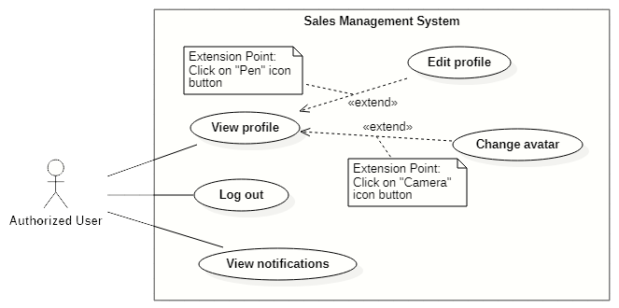

*Figure 6. <<Authorized User>> Overview Use Case*

#### View profile

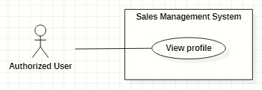

*Figure 7. <<Authorized User>> View profile*

|  |  |  |  |  |  |
| --- | --- | --- | --- | --- | --- |
| ID and Name: | **UC-03 View profile** | | | | |
| Created By: | GiaNH | | Date Created: | 05/02/2021 |
| Primary Actor: | Authorized User | | Secondary Actors: | N/A |
| Description: | This use case allows the user to view his/her profile. | | | | |
| Trigger: | The user selects “Profile” command in the options menu under the user avatar (at the top right corner of the screen). | | | | |
| Preconditions: | PRE-1. The user has been logged into the system. | | | | |
| Post-conditions: | POST-1. The user’s information is displayed in details as a form. | | | | |
| Normal Flow: | **Step** | **Actor Action** | | **System Response** | |
| 1 | The user clicks on the avatar on the right corner of the topbar. | | The system redirects to the “Profile” screen.  The detail information of the user is displayed on the screen.  [Exception 1] | |
| Alternative Flows: | N/A | | | | |
| Exceptions: | **No** | **Cause** | | **System Response** | |
| 1 | The user’s device does not connect to the Internet or the server has internal error. | | The system shows the error message: “Connection Failed or Internal Error”. | |
| Priority: | Normal | | | | |
| Frequency of Use: | Usually | | | | |
| Business Rules: | BR-05 | | | | |
| Other Information: | N/A | | | | |
| Assumptions: | N/A | | | | |

*Table 6. <<Authorized User>> View profile*

#### Edit profile

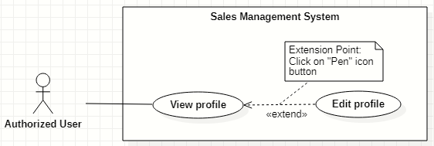

*Figure 8. <<Authorized User>> Edit profile*

|  |  |  |  |  |  |
| --- | --- | --- | --- | --- | --- |
| ID and Name: | **UC-04 Edit profile** | | | | |
| Created By: | GiaNH | | Date Created: | | 05/02/2021 |
| Primary Actor: | Authorized User | | Secondary Actors: | | N/A |
| Description: | This use case allows the user to edit his/her profile. | | | | |
| Trigger: | The user clicks on “Pen” icon button. | | | | |
| Preconditions: | PRE-1. The user has been logged into the system.  PRE-2. The user is at the “Profile” screen. | | | | |
| Post-conditions: | POST-1. The user’s information is edited in the system. | | | | |
| Normal Flow: | **Step** | **Actor Action** | | **System Response** | |
| 1 | On Profile screen, the user clicks on “Pen” icon button at the right of the information row that he/she wants to edit.  [Alternative 1 ] | | At the selected row, the system opens the collapsed div to show the text field with the following format:   * “Password”: text. * “Address”: text. * “Email”: text. * “Birthdate”: date. * “IsMale”: two radio buttons, required, only select one. * “Phone” text. * “Avatar”: image. | |
| 2 | The user inputs the information into the selected text field. | | [Exception 1]  [Exception 2]  [Exception 3] | |
| 3 | The user selects “Save” button.  [Exception 4] | | The system shows the the successful message: “Updated Successfullly”.  [Exception 5] | |
| Alternative Flows: | **Step** | **Actor Action** | | **System Response** | |
| 1 | The user selects “Pen” icon button at “Password” line. | | The system shows the accordion that contains following information:   * “Current Password”: text, required. * “New Password”: text, required. * “Confirm New Password”: text, required.   *Continue to step 2 of Normal Flow*. | |
| Exceptions: | **No** | **Cause** | | **System Response** | |
| 1 | The user inputs invalid format content into fields. | | The system shows the error message: “Incorrect entry”. | |
| 2 | The user inputs the wrong old password. | | The system shows the error message: “Invalid password” and “Update Unsuccessful”. | |
| 3 | The user inputs the confirm-new password that does not match to new password. | | The system shows the error message: “You must enter the same password twice in order to confirm it”. | |
| 4 | The user selects “Cancel” button to cancel updating. | | The system discards all changes and returns the “Profile” screen. | |
| 5 | The user’s device does not connect to the Internet or the server has internal error. | | The system shows the error message: “Connection Failed or Internal Error”. | |
| Priority: | Normal | | | | |
| Frequency of Use: | Usually | | | | |
| Business Rules: | * BR-05 * All fields related to “password” must be 8 – 30 characters length and must be hashed encrypted. * Fields that could be edited are: password, email, phone number, address and avatar. * Phone must be in format “/(84|0[3|5|7|8|9])+([0-9]{8})\b/g” and have max length is 10 (when starts with 0) or 11 (when starts with 84).   *(Resources:* [*https://www.regextester.com/106725*](https://www.regextester.com/106725)*)*   * Fields which are not allowed users to edit are: username, fullname, birthdate and isMale. | | | | |
| Other Information: | N/A | | | | |
| Assumptions: | N/A | | | | |

*Table 7. <<Authorized User>> Edit profile*

#### Change avatar

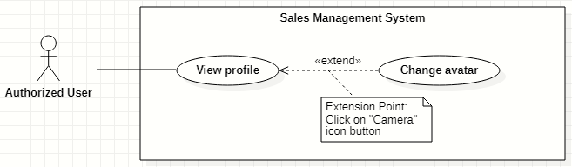

*Figure 9. <<Authorized User>> Change avatar*

|  |  |  |  |  |  |
| --- | --- | --- | --- | --- | --- |
| ID and Name: | **UC-05 Change avatar** | | | | |
| Created By: | HaPTN | | Date Created: | | 12/04/2021 |
| Primary Actor: | Authorized User | | Secondary Actors: | | N/A |
| Description: | This use case allows the user to update his/her profile avatar. | | | | |
| Trigger: | The user clicks on “Camera” icon button next to the avatar. | | | | |
| Preconditions: | PRE-1. The user has been logged into the system.  PRE-2. The user is at the “Profile” screen. | | | | |
| Post-conditions: | POST-1. The user’s new avatar is edited in the system. | | | | |
| Normal Flow: | **Step** | **Actor Action** | | **System Response** | |
| 1 | On Profile screen, the user clicks on “Camera” icon button next to the avatar image. | | The system opens the Windows Explorer dialog for user to upload an image. | |
| 2 | The user chooses an image in the Windows Explorer dialog and clicks on “Open” button.  [Exception 1]  [Exception 2] | | The system updates avatar with the chosen image and shows the the successful message: “Updated Successfullly”.  [Exception 3] | |
| Alternative Flows: | N/A | | | | |
| Exceptions: | **No** | **Cause** | | **System Response** | |
| 1 | The user chooses invalid image format. | | The system shows the error message: “Update Unsuccessful”. | |
| 2 | The user closes the Windows Explorer (by clicking on “x” button or “Cancel” button). | | The system shows the error message: “Update Unsuccessful”. | |
| 3 | The user’s device does not connect to the Internet or the server has internal error. | | The system shows the error message: “Connection Failed or Internal Error”. | |
| Priority: | Normal | | | | |
| Frequency of Use: | Usually | | | | |
| Business Rules: | * BR-05 * In the Windows Explorer dialog, the user can only choose one image at a time. * The system only accepts image files in type “.png”, “.jpg”, “.jpeg”. | | | | |
| Other Information: | N/A | | | | |
| Assumptions: | N/A | | | | |

*Table 8. <<Authorized User>> Change avatar*

#### Logout

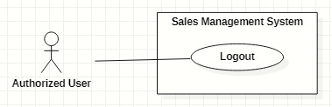

*Figure 10. <<Authorized User>> Logout*

|  |  |  |  |  |  |  |
| --- | --- | --- | --- | --- | --- | --- |
| ID and Name: | **UC-06 Logout** | | | | | |
| Created By: | GiaNH | | Date Created: | 05/02/2021 | |
| Primary Actor: | Authorized User | | Secondary Actors: | N/A | |
| Description: | This use case allows the users to log out of the system. | | | | | |
| Trigger: | The user clicks on “Logout” button. | | | | | |
| Preconditions: | PRE-1. The user has been logged into the system. | | | | | |
| Post-conditions: | POST-1. The user logs out the system. | | | | | |
| Normal Flow: | **Step** | **Actor Action** | | | **System Response** | |
| 1 | The user clicks on the “Avatar” icon button to open “Profile” screen. | | | The system redirects to the “Profile” screen. | |
| 2 | The user clicks on “Log out” button at the top right corner of the “Profile” screen. | | | The system clears cookies and access token then returns to the “Login” screen. | |
| Alternative Flows: | N/A | | | | | |
| Exceptions: | N/A | | | | | |
| Priority: | Normal | | | | | |
| Frequency of Use: | Usually | | | | | |
| Business Rules: | User’s token is removed in client and the session is destroyed in server. | | | | | |
| Other Information: | N/A | | | | | |
| Assumptions: | N/A | | | | | |

*Table 9. <<Authorized User>> Logout*

#### View notifications

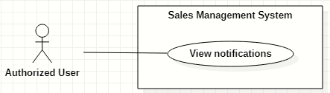

*Figure 11. <<Authorized User>> View notifications*

|  |  |  |  |  |  |  |
| --- | --- | --- | --- | --- | --- | --- |
| ID and Name: | **UC-07 View notifications** | | | | | |
| Created By: | HaPTN | | Date Created: | 12/04/2021 | |
| Primary Actor: | Authorized User | | Secondary Actors: | N/A | |
| Description: | This use case allows the users. | | | | | |
| Trigger: | The user clicks on “Bell” icon button (at the top right corner of the screen). | | | | | |
| Preconditions: | PRE-1. The user has been logged into the system. | | | | | |
| Post-conditions: | POST-1. The user is redirect to the corresponding screen depends on what notification he/she selects. | | | | | |
| Normal Flow: | **Step** | **Actor Action** | | | **System Response** | |
| 1 | The user clicks on “Bell” icon button (at the top right corner of the screen) to view list of notifications. | | | The system shows list of notifications in a popover, near the “Bell” icon button. | |
|  | 2 | The user select specific notification.  [Alternative 1]  [Alternative 2] | | | [Exception 1] | |
| Alternative Flows: | **Step** | **Actor Action** | | | **System Response** | |
| 1 | The user clicks on notification type “report”. | | | The system redirects to “Report details” screen for user to view comment of supervisor/manager. | |
| 2 | The user clicks on notification type “memorandum”. | | | The system redirects to “Memorandum details” screen for user to view memorandum’s details. | |
| Exceptions: | **No** | **Cause** | | | **System Response** | |
| 1 | The user’s device does not connect to the Internet or the server has internal error. | | | The system shows the error message: “Connection Failed or Internal Error”. | |
| Priority: | Normal | | | | | |
| Frequency of Use: | Usually | | | | | |
| Business Rules: | * BR-26 (notification type “report”) * BR-33 (notification type “memorandum”) | | | | | |
| Other Information: | N/A | | | | | |
| Assumptions: | N/A | | | | | |

*Table 10. <<Authorized User>> View notifications*

### 2.4 <<Administrator>> Overview Use Case

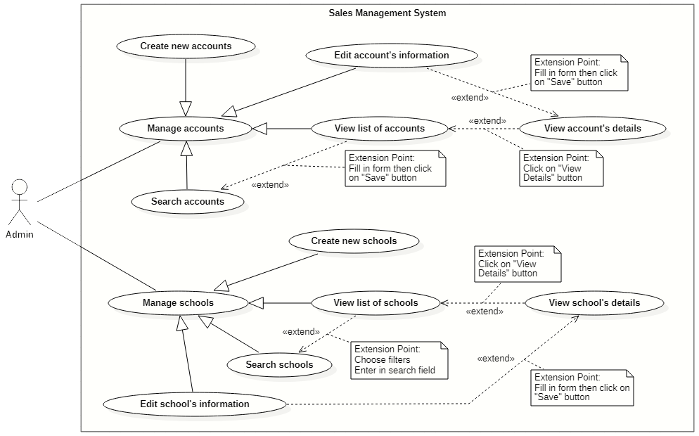

*Figure 12. <<Administrator>> Overview Use Case*

#### Create new accounts

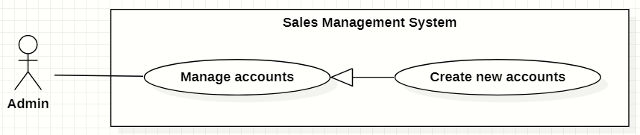

*Figure 13. <<Administrator>> Create new accounts*

|  |  |  |  |  |  |
| --- | --- | --- | --- | --- | --- |
| ID and Name: | **UC-08 Create new accounts** | | | | |
| Created By: | GiaNH | | Date Created: | | 15/02/2021 |
| Primary Actor: | Administrator | | Secondary Actors: | | N/A |
| Description: | This use case allows the user to create new account. | | | | |
| Trigger: | The user clicks on the “Create” button in “Accounts” screen. | | | | |
| Preconditions: | PRE-1. The user has been logged into the system with role Admin.  PRE-2. The user is on the “Accounts” screen. | | | | |
| Post-conditions: | POST-1. The new account is added in the system. | | | | |
| Normal Flow: | **Step** | **Actor Action** | | **System Response** | |
| 1 | The user selects “Accounts” on the navigation bar (sidebar). | | The system redirects the Accounts screen. | |
| 2 | The user selects on “Create” button in screen. | | The system displays the “Create Account” form with the following required information:   * “Username”: input text filed, required. * “Role”: selections (Salesman, Sales Supervisor, Sales Manager, Admin). * “Full name”: input text field, required. * “Email”: input text field. * “Phone”: input text field, required. * “Address”: input text field. * “IsMale”: radio buttons, required. * “Birthdate”: date picker. * “Save”: button. * “Cancel”: button. | |
| 3 | The user inputs into required information fields. | | [Exception 1]  [Exception 2] | |
| 4 | The user selects on the “Save” button.  [Exception 4] | | The system shows the successful message: “New account has been created successfully. Please check your email to get the password.”.  [Exception 3]  [Exception 5] | |
| 5 |  | | The system sends the new user an email which contains the his/her password.  [Exception 3] | |
| 6 |  | | The system updates the table of list of schools in the “Schools” screen.  [Exception 3] | |
| Alternative Flows: | N/A | | | | |
| Exceptions: | **No** | **Cause** | | **System Response** | |
| 1 | The user leaves the blank fields or inputs the invalid format content. | | The system shows the error message: “Please input the valid format content”. | |
| 2 | The content that the user inputs into “Confirm password” is not matched the “Password” field. | | The system show the error message: “Confirm password is not matched the password”. | |
| 3 | The user’s device does not connect to the Internet or the server has internal error. | | The system shows the error message: “Connection Failed or Internal Error”. | |
| 4 | The user selects “Cancel” button. | | The system closes the “Create Account” view and returns the “Accounts” screen. | |
| 5 | The content that the user inputs into “username” field is duplicate in the system. | | The system shows the error message: “The username has already existed”. | |
| Priority: | High | | | | |
| Frequency of Use: | Usually | | | | |
| Business Rules: | * BR-04, BR-09 * The username must be 8 – 30 characters, not include special characters. * Admin does not create password for users. * Password is randomly generated by the system and is sent to the provided user’s email. * The password which is stored in the Database must be hasheded encrypted by Bcript. * The email must be validated. * Phone must be in format “/(84|0[3|5|7|8|9])+([0-9]{8})\b/g” and have max length is 10 (when starts with 0) or 11 (when starts with 84).   *(Resources:* [*https://www.regextester.com/106725*](https://www.regextester.com/106725)*)* | | | | |
| Other Information: | N/A | | | | |
| Assumptions: | N/A | | | | |

*Table 11. <<Administrator>> Create new accounts*

#### Search accounts

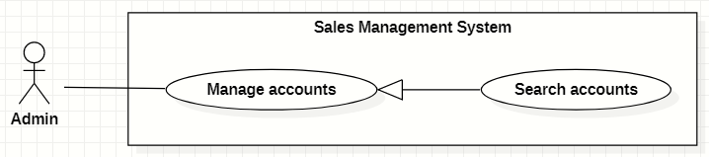

*Figure 14. <<Administrator>> Search accounts*

|  |  |  |  |  |  |  |  |
| --- | --- | --- | --- | --- | --- | --- | --- |
| ID and Name: | **UC-09 Search accounts** | | | | | | |
| Created By: | GiaNH | | | Date Created: | | | 16/02/2021 |
| Primary Actor: | Administrator | | | Secondary Actors: | | | N/A |
| Description: | This use case allows the users to find the accounts based on the role, status, username, phone, address,… | | | | | | |
| Trigger: | The user selects filters or inputs in search field on the “Accounts” screen. | | | | | | |
| Preconditions: | PRE-1. The user has been logged into the system with role Admin.  PRE-2. The user is on “Accounts” screen. | | | | | | |
| Post-conditions: | POST-1. The list of accounts is shown. | | | | | | |
| Normal Flow: | **Step** | | **Actor Action** | | **System Response** | | |
| 1 | | The user inputs in the search field or selects filters to looking for accounts. | | The system displays the list of accounts as the table.  Available filters on this screen:   * “isActive”: selections (true, false) * “Roles”: selections (Admin, Sales Manager, Sales Supervisor, Salesman). * Search field: text field. | | |
| 2 | |  | | The list of Accounts is shown as a table on the Accounts screen.  Table will includes these fields:   * “Username”: text. * “Fullname”: image (avatar) and text. * “Phone”: text. * “Email”: text. * “Role”: Label. | | |
| Alternative Flows: | N/A | | | | | | |
| Exceptions: | **No** | **Cause** | | | | **System Response** | |
| 1 | The content of search field or selecting filter that the user inputted is not matched any data in database. | | | | The system displays “No records found” line. | |
| Priority: | Normal | | | | | | |
| Frequency of Use: | Usually | | | | | | |
| Business Rules: | * The default values of filter “isActive” is “true” * The default values of filter “Role” is “All”. | | | | | | |
| Other Information: | N/A | | | | | | |
| Assumptions: | N/A | | | | | | |

*Table 12. <<Administrator>> Search accounts*

#### View list of accounts

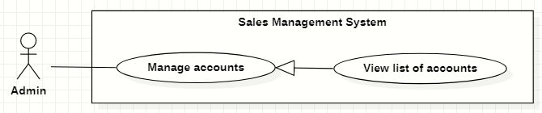

*Figure 15. <<Administrator>> View list of accounts*

|  |  |  |  |  |  |
| --- | --- | --- | --- | --- | --- |
| ID and Name: | **UC-10 View list of accounts** | | | | |
| Created By: | GiaNH | | Date Created: | | 15/02/2021 |
| Primary Actor: | Administrator | | Secondary Actors: | | N/A |
| Description: | This use case allows the user to view list of accounts. | | | | |
| Trigger: | The user selects “Accounts” on the navigation bar (sidebar). | | | | |
| Preconditions: | PRE-1. The user has been logged into the system with role Admin. | | | | |
| Post-conditions: | POST-1. The list of Accounts is shown as a table on the “Accounts” screen. | | | | |
| Normal Flow: | **Step** | **Actor Action** | | **System Response** | |
| 1 | The user selects “Accounts” on the navigation bar (sidebar). | | The system redirects the Accounts screen. | |
| 2 |  | | The list of Accounts is shown as a table on the Accounts screen.  Table will includes these fields:   * “Username”: text. * “Fullname”: image (avatar) and text. * “Phone”: text. * “Email”: text. * “Role”: Label. | |
| Alternative Flows: | N/A | | | | |
| Exceptions: | **No** | **Cause** | | **System Response** | |
| 1 | The data is null or empty in database. | | The system shows “No records found” line on the table. | |
| Priority: | Medium | | | | |
| Frequency of Use: | Usually | | | | |
| Business Rules: | * The default values of filter “isActive” is “true” * The default values of filter “Role” is “All”. | | | | |
| Other Information: | N/A | | | | |
| Assumptions: | N/A | | | | |

*Table 13. <<Administrator>> View list of accounts*

#### View account’s details

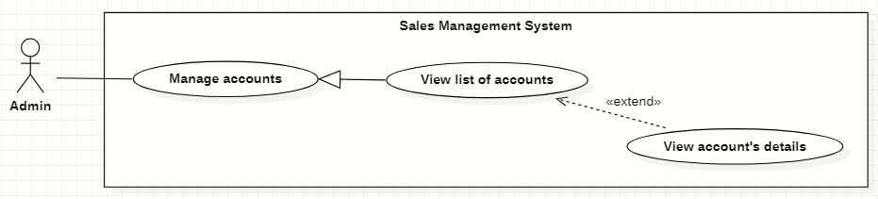

*Figure 16. <<Administrator>> View account’s details*

|  |  |  |  |  |  |
| --- | --- | --- | --- | --- | --- |
| ID and Name: | **UC-11 View account’s details** | | | | |
| Created By: | GiaNH | | Date Created: | | 16/02/2021 |
| Primary Actor: | Administrator | | Secondary Actors: | | N/A |
| Description: | This use case allows the user to view the detail information of an account. | | | | |
| Trigger: | The user clicks on the “View details” command on the menu options at the end of row in table list of accounts. | | | | |
| Preconditions: | PRE-1. The user has been logged into the system with role Admin.  PRE-2. The user is on the “Accounts” screen. | | | | |
| Post-conditions: | POST-1. The detail information of account is shown as a form. | | | | |
| Normal Flow: | **Step** | **Actor Action** | | **System Response** | |
| 1 | On the “Accounts” screen, at the end of each row in the table, the user clicks on action icon button, then selects “View detail” command on the menu options. | | The system displays “Account’s details” view, the account’s information is displayed as a form.   * “Username”: input text filed, required. * “Password”: input password text field, required. * “Confirm password: input password text field, required. * “Role”: selections (Salesman, Sales Supervisor, Sales Manager, Admin). * “Full name”: input text field, required. * “Email”: input text field. * “Phone”: input text field, required. * “IsMale”: radio buttons, required. * “Birthdate”: date picker. * “Address”: input text field. * “Save”: button, inactive. | |
| Alternative Flows: | N/A | | | | |
| Exceptions: | N/A | | | | |
| Priority: | Medium | | | | |
| Frequency of Use: | Usually | | | | |
| Business Rules: | N/A | | | | |
| Other Information: | N/A | | | | |
| Assumptions: | N/A | | | | |

*Table 14. <<Administrator>> View account’s details*

#### Edit account’s information

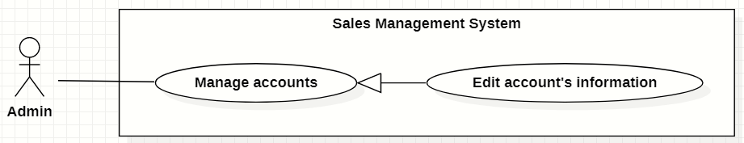

*Figure 17. <<Administrator>> Edit account’s information*

|  |  |  |  |  |  |  |  |
| --- | --- | --- | --- | --- | --- | --- | --- |
| ID and Name: | **UC-12 Edit account’s information** | | | | | | |
| Created By: | GiaNH | | | Date Created: | | | 16/02/2021 |
| Primary Actor: | Administrator | | | Secondary Actors: | | | N/A |
| Description: | This use case allows the users to edit the account’s information. | | | | | | |
| Trigger: | The user edits on fields in “Account’s details” screen then clicks “Save” button. | | | | | | |
| Preconditions: | PRE-1. The user has been logged into the system with role Admin.  PRE-2. The user is on the “Account’s details” screen. | | | | | | |
| Post-conditions: | POST-1. The Account information is edited in database. | | | | | | |
| Normal Flow: | **Step** | | **Actor Action** | | | **System Response** | |
| 1 | |  | | | The system displays the “Account’s detail” screen as a form with the following required information:   * “Username”: text field, disabled. * “Full name”: input text field. * “Email”: input text field. * “Phone”: input text field, required. * “IsMale”: radio buttons. * “Birthdate”: date picker. * “Address”: input text field. * “Roles”: selections (Admin, Sales Manager, Sales Supervisor, Salesman). * “isActive”: toggle, required. * “Save”: button, only active when the form is dirty. | |
| 2 | | The user edits on fields in this form. | | | [Exception 1] | |
| 3 | | The user clicks “Save” button when finish. | | | The system has successful edit and displays the successful message: “Updated Successfully”. [Exception 2] | |
| Alternative Flows: | N/A | | | | | | |
| Exceptions: | **No** | **Cause** | | | **System Response** | | |
| 1 | The user inputs invalid format content into fields. | | | The system informs the users that the content of fields is invalid format. | | |
| 2 | The user’s device does not connect to the Internet or the server has internal error. | | | The system shows the error message: “Connection Failed or Internal Error”. | | |
| Priority: | Medium | | | | | | |
| Frequency of Use: | Usually | | | | | | |
| Business Rules: | * BR-06, BR-08, BR-09 * Phone must be in format “/(84|0[3|5|7|8|9])+([0-9]{8})\b/g” and have max length is 10 (when starts with 0) or 11 (when starts with 84).   *(Resources:* [*https://www.regextester.com/106725*](https://www.regextester.com/106725)*)* | | | | | | |
| Other Information: | N/A | | | | | | |

*Table 15. <<Administrator>> Edit account’s information*

#### Create new schools

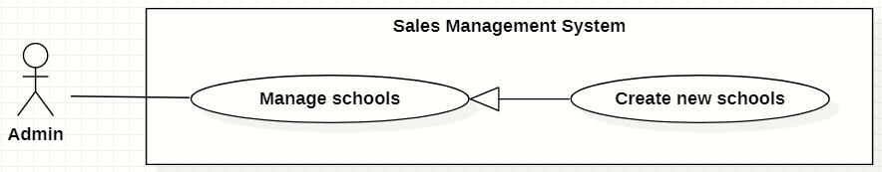

*Figure 18. <<Administrator>> Create new schools*

|  |  |  |  |  |  |  |  |
| --- | --- | --- | --- | --- | --- | --- | --- |
| ID and Name: | **UC-13 Create new schools** | | | | | | |
| Created By: | GiaNH | | | | Date Created: | | 15/02/2021 |
| Primary Actor: | Administrator | | | | Secondary Actors: | | N/A |
| Description: | This use case allows the user to create new school. | | | | | | |
| Trigger: | The user clicks on the “Create” button in “Schools” screen. | | | | | | |
| Preconditions: | PRE-1. The user has been logged into the system with role Admin.  PRE-2. The user is on the “Schools” screen. | | | | | | |
| Post-conditions: | POST-1. The new account is added in the system. | | | | | | |
| Normal Flow: | **Step** | | **Actor Action** | | | **System Response** | |
| 1 | | The user selects “Schools” on the navigation bar (sidebar). | | | The system redirects to the “Schools” screen. | |
| 2 | | The user hovers on “Create” button in screen. | | | The systems shows a menu list which contains two options (“Import”, “Create a school”). | |
| 3 | | The user clicks on “Create a school” option in the menu list.  [Alternative 1] | | | The system displays the “Create new schools” form with the following required information:  *School’s information:*   * “School name”: input text filed, required. * “School phone”: input text field. * “District”: selections, required. * “Address”: input text field. * “isActive”: boolean, default value is true. * “Description”: input text field. * “School type”: selections (Công lập, Ngoài công lập, Bán công), required. * “Educational level”: selections (Tiểu học, THCS, THPT), required. * “School scale”: selections (Lớn, Vừa, Nhỏ).   “School status”: selections (Leads, Customer, Ngưng hợp tác).  *Representative’s information:*   * “Full name”: input text field. * “Email”: input text field. * “Phone”: input text field. * “IsMale”: radio buttons. * “Cancel”: button. * “Save”: button. | |
| 4 | | The user inputs into information fields. | | | [Exception 1] | |
| 5 | | The user selects on the “Save” button.  [Exception 3] | | | The system shows the successful message: “Create Successfully”.  [Exception 2] | |
| 6 | |  | | | The system updates the table of list of schools in the “Schools” screen.  [Exception 2] | |
| Alternative Flows: | **No** | **Step** | | **Actor Action** | | **System Response** | |
| 1 | 1 | | The user clicks on “Import” option in the menu list. | | The system displays the “Import” dialog which contains:   * “You can download the sample template *here*”: text, link. * “Browse”: button. * “Cancel”: button. * “Save”: button. | |
| 2 | | The user clicks on “Browse” button to upload a file from the device.  [Alternative 1.1]  [Exception 4]  [Exception 5]  [Exception 6] | | The system displays the Windows Explorer dialog for user to retrieve file in user’s device. | |
| 3 | | The user selects the file to import and chooses confirm command.  [Exception 2] | | The system shows the selected file’s name on the “Import” dialog. | |
| 4 | | The users clicks on “Save” button.  [Alternative 1.2]  [Exception 3] | | The system shows the successful message: “Create Successfully”.  *Continue to the step 6 in Normal Flow.* | |
| 1.1 | 1 | | The user clicks on “You can download the sample template *here*” link. | | The systems downloads a sample Excel file to the user’s device. | |
| 2 | | The users add data in that Excel file and upload it. | | *Continue to the step 2 in the Alternative Flow 1.* | |
| 1.2 | 1 | | The user clicks on “Browse” button again and chooses another file to upload. | | *Continue to the step 3 in the Alternative Flow 1.* | |
| Exceptions: | **No** | | **Cause** | | | **System Response** | |
| 1 | | The user leaves the blank fields or inputs the invalid format content. | | | The system shows the error message: “Please input the valid format content”. | |
| 2 | | The user’s device does not connect to the Internet or the server has internal error. | | | The system shows the error message: “Connection Failed or Internal Error”. | |
| 3 | | The user selects “Cancel” button. | | | The system closes the “Create School” view and returns the “Schools” screen. | |
| 4 | | The user chooses invalid image format. | | | The system shows the error message: “Please choose the right file format”. | |
| 5 | | The size of file is larger than 5MB. | | | The system shows the error message: “This file is too large. Please choose file with size within 5MB”. | |
| 6 | | The user closes the Windows Explorer (by clicking on “x” button or “Cancel” button). | | | The system closes the Windows Explorer and does not shows anything errors or messages. | |
| Priority: | High | | | | | | |
| Frequency of Use: | Usually | | | | | | |
| Business Rules: | * BR-09, BR-10 * Phone must be in format “/(84|0[3|5|7|8|9])+([0-9]{8})\b/g” and have max length is 10 (when starts with 0) or 11 (when starts with 84).   *(Resources:* [*https://www.regextester.com/106725*](https://www.regextester.com/106725)*)*   * The system only accepts Excel files in type “.xlsx”, “.xls”, “.csv”, “.xslx” or “.xml”. * The size of file is no larger than 5MB. * In the Windows Explorer dialog, the user can only choose one file at a time. | | | | | | |
| Other Information: | N/A | | | | | | |
| Assumptions: | N/A | | | | | | |

*Table 16. <<Administrator>> Create new schools*

#### Search schools

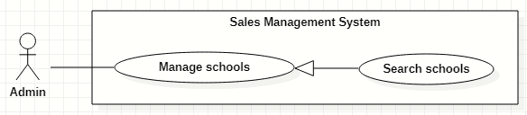

*Figure 19. <<Administrator>> Search schools*

|  |  |  |  |  |  |  |  |
| --- | --- | --- | --- | --- | --- | --- | --- |
| ID and Name: | **UC-14 Search schools** | | | | | | |
| Created By: | GiaNH | | | Date Created: | | | 16/02/2021 |
| Primary Actor: | Administrator | | | Secondary Actors: | | | N/A |
| Description: | This use case allows the users to find the schools based on school’s name, district, school status, school educational level, school type, address,… | | | | | | |
| Trigger: | The user selects filters or inputs in search field on the “Schools” screen. | | | | | | |
| Preconditions: | PRE-1. The user has been logged into the system with role Admin.  PRE-2. The user is on “Schools” screen. | | | | | | |
| Post-conditions: | POST-1. The list of schools is shown. | | | | | | |
| Normal Flow: | **Step** | | **Actor Action** | | **System Response** | | |
| 1 | | The user inputs in the search field or selects filters to looking for schools. | | The system displays the list of accounts as the table.  Available filters on this screen:   * “Districts”: selections (24 districts in Ho Chi Minh City) * “School Statuses”: selections (Leads, Customer, Ngưng hợp tác). * “School Types”: selections (Công lập, Ngoài công lập, Bán công). * “School Levels”: selections (Tiểu học, THCS, THPT). * “School Scales”: selections (Lớn, Vừa, Nhỏ). * Search field: text field. | | |
| 2 | |  | | The list of Schools is shown as a table on the “Schools” screen.  Table will includes these fields:   * “School Name”: text. * “Address”: text. * “Principal”: text. * “Status”: Label. | | |
| Alternative Flows: | N/A | | | | | | |
| Exceptions: | **No** | **Cause** | | | | **System Response** | |
| 1 | The content of search field or selecting filter that the user inputted is not matched any data in database. | | | | The system displays “No records found” line. | |
| Priority: | Normal | | | | | | |
| Frequency of Use: | Usually | | | | | | |
| Business Rules: | The default values of all filters are “All”. | | | | | | |
| Other Information: | N/A | | | | | | |
| Assumptions: | N/A | | | | | | |

*Table 17. <<Administrator>> Search schools*

#### View list of schools

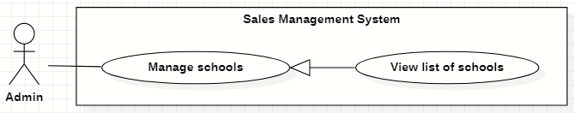

*Figure 20. <<Administrator>> View list of schools*

|  |  |  |  |  |  |
| --- | --- | --- | --- | --- | --- |
| ID and Name: | **UC-15 View list of schools** | | | | |
| Created By: | GiaNH | | Date Created: | | 15/02/2021 |
| Primary Actor: | Administrator | | Secondary Actors: | | N/A |
| Description: | This use case allows the user to view list of schools. | | | | |
| Trigger: | The user selects “Schools” on the navigation bar (sidebar). | | | | |
| Preconditions: | PRE-1. The user has been logged into the system with role Admin. | | | | |
| Post-conditions: | POST-1. The list of Schools is shown as a table on the “Schools” screen. | | | | |
| Normal Flow: | **Step** | **Actor Action** | | **System Response** | |
| 1 | The user selects “Schools” on the navigation bar (sidebar). | | The system redirects the “Schools” screen. | |
| 2 |  | | The list of Schools is shown as a table on the “Schools” screen.  Table will includes these fields:   * “School Name”: text. * “Address”: text. * “Principal”: text. * “Status”: Label. | |
| Alternative Flows: | N/A | | | | |
| Exceptions: | **No** | **Cause** | | **System Response** | |
| 1 | The data is null or empty in database. | | The system shows “No records found” line on the table. | |
| Priority: | Medium | | | | |
| Frequency of Use: | Usually | | | | |
| Business Rules: | The default values of all filters are “All”. | | | | |
| Other Information: | N/A | | | | |
| Assumptions: | N/A | | | | |

*Table 18. <<Administrator>> View list of schools*

#### View school’s details

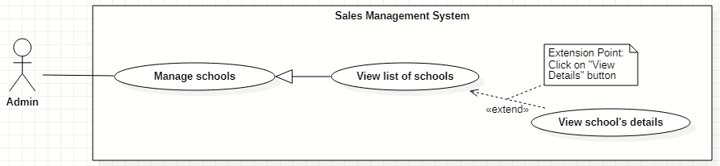

*Figure 21. <<Administrator>> View school’s details*

|  |  |  |  |  |  |
| --- | --- | --- | --- | --- | --- |
| ID and Name: | **UC-16 View school’s details** | | | | |
| Created By: | GiaNH | | Date Created: | | 16/02/2021 |
| Primary Actor: | Administrator | | Secondary Actors: | | N/A |
| Description: | This use case allows the user to view the detail information of a school. | | | | |
| Trigger: | The user clicks on the “View details” command on the menu options at the end of row in table list of schools. | | | | |
| Preconditions: | PRE-1. The user has been logged into the system with role Admin.  PRE-2. The user is on the “Schools” screen. | | | | |
| Post-conditions: | POST-1. The detail information of school is shown as a form. | | | | |
| Normal Flow: | **Step** | **Actor Action** | | **System Response** | |
| 1 | On the “Schools” screen, at the end of each row in the table, the user clicks on action icon button, then selects “View detail” command on the menu options. | | The system displays “School’s details” view, the school’s information is displayed as a form.  *School’s information:*   * “School name”: input text filed, required. * “School phone”: input text field. * “District”: selections (24 districts in Ho Chi Minh City). * “Address”: input text field. * “isActive”: boolean, default value is true. * “Description”: input text field. * “School type”: selections (Công lập, Ngoài công lập, Bán công), required. * “Educational level”: selections (Tiểu học, THCS, THPT), required. * “School scale”: selections (Lớn, Vừa, Nhỏ). * “School status”: selections (Leads, Customer, Ngưng hợp tác).   *Representative’s information:*   * “Full name”: input text field. * “Email”: input text field. * “Phone”: input text field. * “IsMale”: radio buttons (Male, Female). | |
| Alternative Flows: | N/A | | | | |
| Exceptions: | N/A | | | | |
| Priority: | Medium | | | | |
| Frequency of Use: | Usually | | | | |
| Business Rules: | N/A | | | | |
| Other Information: | N/A | | | | |
| Assumptions: | N/A | | | | |

*Table 19. <<Administrator>> View school’s details*

#### Edit school’s information

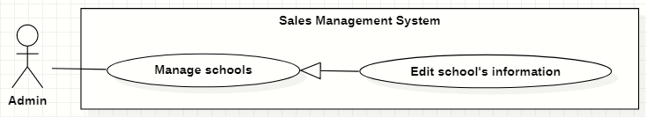

*Figure 22. <<Administrator>> Edit school’s information*

|  |  |  |  |  |  |  |  |
| --- | --- | --- | --- | --- | --- | --- | --- |
| ID and Name: | **UC-17 Edit school’s information** | | | | | | |
| Created By: | GiaNH | | | Date Created: | | | 16/02/2021 |
| Primary Actor: | Administrator | | | Secondary Actors: | | | N/A |
| Description: | This use case allows the users to edit the school’s information. | | | | | | |
| Trigger: | The user edits on fields in “School’s details” screen then clicks “Save” button. | | | | | | |
| Preconditions: | PRE-1. The user has been logged into the system with role Admin.  PRE-2. The user is on the “School’s details” screen. | | | | | | |
| Post-conditions: | POST-1. The School information is edited in database. | | | | | | |
| Normal Flow: | **Step** | | **Actor Action** | | | **System Response** | |
| 1 | |  | | | The system displays the “School’s detail” screen as a form with the following required information:  *School’s information:*   * “School name”: input text filed, required. * “School phone”: input text field. * “District”: selections (24 districts in Ho Chi Minh City). * “Address”: input text field. * “isActive”: boolean, default value is true. * “Description”: input text field. * “School type”: selections (Công lập, Ngoài công lập, Bán công), required. * “Educational level”: selections (Tiểu học, THCS, THPT), required. * “School scale”: selections (Lớn, Vừa, Nhỏ). * “School status”: selections (Leads, Customer, Ngưng hợp tác). * “Save”: button, only active when the form is dirty.   *Representative’s information:*   * “Full name”: input text field. * “Email”: input text field. * “Phone”: input text field. * “IsMale”: radio buttons (Male, Female). * “Save”: button, only active when the form is dirty. | |
| 2 | | The user edits on fields in this form.  [Exception 1] | | |  | |
| 3 | | The user clicks “Save” button when finish. | | | The system has successful edit and displays the successful message: “Updated Successfully”.  [Exception 2] | |
| Alternative Flows: | N/A | | | | | | |
| Exceptions: | **No** | **Cause** | | | **System Response** | | |
| 1 | The user inputs invalid format content into fields. | | | The system informs the users that the content of fields is invalid format. | | |
| 2 | The user’s device does not connect to the Internet or the server has internal error. | | | The system shows the error message: “Connection Failed or Internal Error”. | | |
| Priority: | Medium | | | | | | |
| Frequency of Use: | Usually | | | | | | |
| Business Rules: | * BR-09 * Phone must be in format “/(84|0[3|5|7|8|9])+([0-9]{8})\b/g” and have max length is 10 (when starts with 0) or 11 (when starts with 84).   *(Resources:* [*https://www.regextester.com/106725*](https://www.regextester.com/106725)*)* | | | | | | |
| Other Information: | N/A | | | | | | |

*Table 20. <<Administrator>> Edit school’s information*

### 2.5 <<Salesman>> Overview Use Case

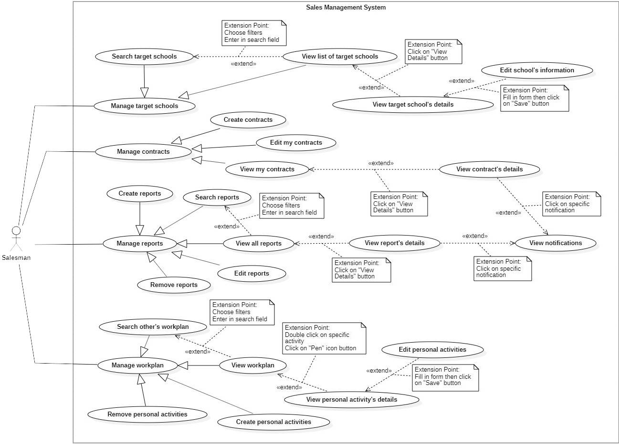

*Figure 23. <<Salesman>> Overview Use Case*

#### Search target schools

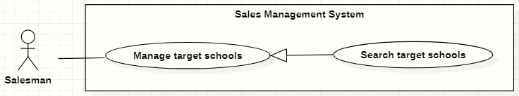

*Figure 24. <<Salesman>> Search target schools*

|  |  |  |  |  |  |
| --- | --- | --- | --- | --- | --- |
| ID and Name: | **UC-18 Search target schools** | | | | |
| Created By: | GiaNH | | Date Created: | | 07/02/2021 |
| Primary Actor: | Salesman, Sales Supervisor, Sales Manager | | Secondary Actors: | | N/A |
| Description: | This use case allows the users to find the target schools based on school’s name, district, school status, school educational level, school type, address,… | | | | |
| Trigger: | The user selects filters or inputs in search field on the “Target Schools” screen. | | | | |
| Preconditions: | PRE-1. The user has been logged into the system with role Salesman, Sales Supervisor or Sales Manager.  PRE-2. The user is on the “Target Schools” screen. | | | | |
| Post-conditions: | POST-1. The list of target schools is shown as a table. | | | | |
| Normal Flow: | **Step** | **Actor Action** | | **System Response** | |
| 1 | The user inputs in the search field or selects filters to looking for schools. | | The system displays the list of accounts as the table.  Available filters on this screen:   * “Purposes”: selections (   - Leads: Sales mới, Theo dõi;  - Customer: Chăm sóc, Tái ký hợp đồng, Ký mới hợp đồng;  - Ngưng hợp tác  )   * “Districts”: selections (24 districts in Ho Chi Minh City) * “School Years”: selections (2020-2021, 2019-2020, 2018-2019,…). * “School Types”: selections (Công lập, Ngoài công lập, Bán công). * “School Levels”: selections (Tiểu học, THCS, THPT). * “School Scales”: selections (Lớn, Vừa, Nhỏ). * Search field: text field. | |
| 2 |  | | The system displays the list of target schools as a table.   * “School Name”: text. * “Principal”: text. * “School Year”: text. * “Purpose”: Label.   [Exception 1]  [Exception 2] | |
| Alternative Flows: | N/A | | | | |
| Exceptions: | **No** | **Cause** | | **System Response** | |
| 1 | The content of search field or selecting filter that The user inputted do not match any stored data in the system. | | The system displays “No records found” line on the table. | |
| 2 | The user’s device does not connect to the Internet or the server has internal error. | | The system shows the error message: “Connection Failed or Internal Error”. | |
| Priority: | Normal | | | | |
| Frequency of Use: | Usually | | | | |
| Business Rules: | * BR-19, BR-20, BR-40 * The default values of all filters are “All”. | | | | |
| Other Information: | N/A | | | | |
| Assumptions: | N/A | | | | |

*Table 21. <<Salesman>> Search target schools*

#### View list of target schools

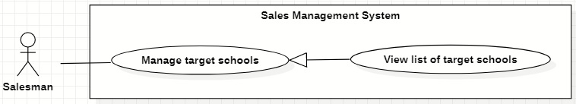

*Figure 25. <<Salesman>> View list of target schools*

|  |  |  |  |  |  |
| --- | --- | --- | --- | --- | --- |
| ID and Name: | **UC-19 View list of target schools** | | | | |
| Created By: | GiaNH | | Date Created: | | 07/02/2021 |
| Primary Actor: | Salesman, Sales Supervisor, Sales Manager | | Secondary Actors: | | N/A |
| Description: | This use case allows the user to view list of his assigned target schools. | | | | |
| Trigger: | The user selects “Target Schools” on the navigation bar (sidebar). | | | | |
| Preconditions: | PRE-1. The user has been logged into the system with role Salesman, Sales Supervisor or Sales Manager. | | | | |
| Post-conditions: | POST-1. The list of target schools is shown as a table. | | | | |
| Normal Flow: | **Step** | **Actor Action** | | **System Response** | |
| 1 | The user selects “Target Schools” on the navigation bar (sidebar). | | The system redirects to the “Target schools” screen and shows the target schools table with following columns:   * “School Name”: text. * “Principal”: text. * “School Year”: text. * “Purpose”: label.   Available filters on this screen:   * “Purposes”: selections (   - Leads: Sales mới, Theo dõi;  - Customer: Chăm sóc, Tái ký hợp đồng, Ký mới hợp đồng;  - Ngưng hợp tác  )   * “Districts”: selections (24 districts in Ho Chi Minh City) * “School Years”: selections (2020-2021, 2019-2020, 2018-2019,…). * “School Types”: selections (Công lập, Ngoài công lập, Bán công). * “School Levels”: selections (Tiểu học, THCS, THPT). * “School Scales”: selections (Lớn, Vừa, Nhỏ). * Search field: text field.   [Exception 1]  [Exception 2] | |
| Alternative Flows: | N/A | | | | |
| Exceptions: | **No** | **Cause** | | **System Response** | |
| 1 | No stored target schools data in the system. | | The system displays “No records found” line on the table. | |
| 2 | The user’s device does not connect to the Internet or the server has internal error. | | The system shows the error message: “Connection Failed or Internal Error”. | |
| Priority: | Normal | | | | |
| Frequency of Use: | Usually | | | | |
| Business Rules: | * BR-19, BR-20, BR-40 * The default values of all filters are “All”. | | | | |
| Other Information: | N/A | | | | |
| Assumptions: | N/A | | | | |

*Table 22. <<Salesman>> View list of target schools*

#### View target school’s details

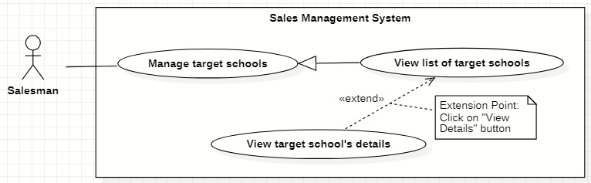

*Figure 26. <<Salesman>> View target school’s details*

|  |  |  |  |  |  |
| --- | --- | --- | --- | --- | --- |
| ID and Name: | **UC-20 View target school’s details** | | | | |
| Created By: | GiaNH | | Date Created: | | 07/02/2021 |
| Primary Actor: | Salesman, Sales Supervisor, Sales Manager | | Secondary Actors: | | N/A |
| Description: | This use case allows the user to view the detail information of the target school. | | | | |
| Trigger: | The user clicks on the “View details” command on the menu options at the end of row in table list of target schools. | | | | |
| Preconditions: | PRE-1. The user has been logged into the system with role Salesman, Sales Supervisor or Sales Manager.  PRE-2. The user is at the “Target Schools” screen. | | | | |
| Post-conditions: | POST-1. The detail information of target school is shown as a form. | | | | |
| Normal Flow: | **Step** | **Actor Action** | | **System Response** | |
| 1 | On the “Target Schools” screen, at the end of each row in the table, the user clicks on action icon button, then selects “View detail” command on the menu options. | | The system shows “Target School’s Details” screen, which contains 3 tabs. Each tab has a form with following information:   1. Tab “General Info”:   *School’s information:*   * “School name”: input text filed, required. * “School phone”: input text field. * “District”: selections (24 districts in Ho Chi Minh City). * “Address”: input text field. * “isActive”: boolean, default value is true. * “Description”: input text field. * “School type”: selections (Công lập, Ngoài công lập, Bán công), required. * “Educational level”: selections (Tiểu học, THCS, THPT), required. * “School scale”: selections (Lớn, Vừa, Nhỏ). * “School status”: selections (Leads, Customer, Ngưng hợp tác).   *Representative’s information:*   * “Full name”: input text field. * “Email”: input text field. * “Phone”: input text field. * “IsMale”: radio buttons (Male, Female).   2> Tab “Assign info”:  *Assign information:*   * “PIC”: text. * “PIC’s phone”: text. * “PIC’s email”: text. * “Purpose”: text. * “Note”: input text field.   3> Tab “Memorandum info”:  *Memorandums information:*   * “ID”: text. * “Duration”: text. * “Services”: check boxes, read only. * “Revenue Criteria”: text. * “Note”: input text field.   [Exception 1] | |
| Alternative Flows: | N/A | | | | |
| Exceptions: | **No** | **Cause** | | **System Response** | |
| 1 | The user’s device does not connect to the Internet or the server has internal error. | | The system shows the error message: “Connection Failed or Internal Error”. | |
| Priority: | Medium | | | | |
| Frequency of Use: | Usually | | | | |
| Business Rules: | * BR-40 * Memorandums belongs to this target school.   If that target school does not have any memorandums, the system does not show this tab to the users. | | | | |
| Other Information: | N/A | | | | |
| Assumptions: | N/A | | | | |

*Table 23. <<Salesman>> View target school’s details*

#### Edit school’s information

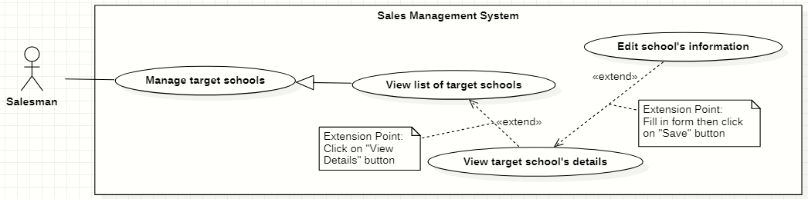

*Figure 27. <<Salesman>> Edit school’s information*

|  |  |  |  |  |  |
| --- | --- | --- | --- | --- | --- |
| ID and Name: | **UC-21 Edit school’s information** | | | | |
| Created By: | HaPTN | | Date Created: | | 12/04/2021 |
| Primary Actor: | Salesman, Sales Supervisor, Sales Manager | | Secondary Actors: | | N/A |
| Description: | This use case allows the user to view the detail information of the target school. | | | | |
| Trigger: | The user edits on fields in “Target School’s details” screen then clicks “Save” button. | | | | |
| Preconditions: | PRE-1. The user has been logged into the system with role Salesman, Sales Supervisor or Sales Manager.  PRE-2. The user is on the tab “General Info” in “Target School’s details” screen. | | | | |
| Post-conditions: | POST-1. The detail information of target school is edited in database. | | | | |
| Normal Flow: | **Step** | **Actor Action** | | **System Response** | |
|  | 1 | The user edits on fields in “Target School’s details” screen then clicks “Save” button. | | The system displays the “Target School’s detail” screen, on the tab “General Info”, there is a form with the following information:  *School’s information:*   * “School name”: input text filed, read only. * “School phone”: input text field, read only. * “District”: selections (24 districts in Ho Chi Minh City), read only. * “Address”: input text field, read only. * “isActive”: boolean, read only. * “Description”: input text field, read only. * “School type”: selections (Công lập, Ngoài công lập, Bán công), read only. * “Educational level”: selections (Tiểu học, THCS, THPT), read only. * “School scale”: selections (Lớn, Vừa, Nhỏ), read only. * “School status”: selections (Leads, Customer, Ngưng hợp tác), read only.   *Representative’s information:*   * “Full name”: input text field. * “Email”: input text field. * “Phone”: input text field. * “IsMale”: radio buttons (Male, Female). * “Save”: button, only active when the form is dirty. | |
|  | 2 | The user edits on fields in this form.  [Exception 1] | |  | |
|  | 3 | The user clicks “Save” button when finish. | | The system edits new data in the database and displays the successful message: “Updated Successfully”.  [Exception 2] | |
| Alternative Flows: | N/A | | | | |
| Exceptions: | **No** | **Cause** | | **System Response** | |
| 1 | The user inputs invalid format content into fields. | | The system informs the users that the content of fields is invalid format. | |
| 2 | The user’s device does not connect to the Internet or the server has internal error. | | The system shows the error message: “Connection Failed or Internal Error”. | |
| Priority: | Medium | | | | |
| Frequency of Use: | Usually | | | | |
| Business Rules: | * BR-30, BR-09, BR-40 * The user can only edit fields related to the school’s representative: full name, isMale, email, phone. * Phone must be in format “/(84|0[3|5|7|8|9])+([0-9]{8})\b/g” and have max length is 10 (when starts with 0) or 11 (when starts with 84).   *(Resources:* [*https://www.regextester.com/106725*](https://www.regextester.com/106725)*)*   * Any school’s data, the user needs to inform to the Admin and only Admin have right to edit school’s information. | | | | |
| Other Information: | N/A | | | | |
| Assumptions: | N/A | | | | |

*Table 24. <<Salesman>> Edit school’s information*

#### Create memorandums

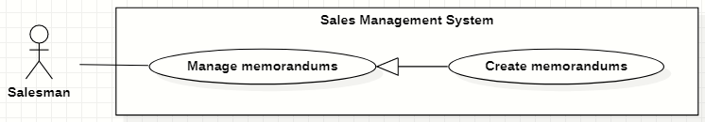

*Figure 28 <<Salesman>> Create memorandums*

|  |  |  |  |  |  |
| --- | --- | --- | --- | --- | --- |
| ID and Name: | **UC-22 Create memorandums** | | | | |
| Created By: | HaPTN | | Date Created: | | 12/04/2021 |
| Primary Actor: | Salesman | | Secondary Actors: | | N/A |
| Description: | This use case allows the user to create memorandums of his/her assigned target schools. | | | | |
| Trigger: | The user selects the “Create” button on “Memorandums” screen. | | | | |
| Preconditions: | PRE-1. The user has been logged into the system with role Salesman, Sales Supervisor or Sales Manager.  PRE-2. The user is on the tab “Memorandums” in “Target School’s details” screen. | | | | |
| Post-conditions: | POST-1. A new memorandum is created in the system. | | | | |
| Normal Flow: | **Step** | **Actor Action** | | **System Response** | |
| 1 | The user selects the “Create” button on “Memorandums” screen. | | The system shows “Create Memorandum” view that contains following information fields:   * “ID”: text. * “Target Schools”: text. * “Duration”: input text field, required. * “Service”: checkbox, required. * “Revenue Criteria”: checkbox, required. * “Note”: input text field, required. | |
| 2 | The user inputs the information into the required fields.  [Exception 1] | |  | |
| 3 | The user selects “Save” button to create a new memorandum.  [Exception 3] | | The system shown the successful message: “Create Successfully”.  [Exception 2] | |
| 4 |  | | The system updates the table of list of memorandums in the “Memorandums” screen.  [Exception 2] | |
| Alternative Flows: | N/A | | | | |
| Exceptions: | **No** | **Cause** | | **System Response** | |
| 1 | The user leaves the blank fields or inputs invalid format content. | | The system shows the error message: “Please input the valid format content”. | |
| 2 | The user’s device does not connect to the Internet or the server has internal error. | | The system shows the error message: “Connection Failed or Internal Error”. | |
| 3 | The user selects “Cancel” button. | | The system closes the “Create Memorandum” view and returns the Memorandums screen. | |
| Priority: | High | | | | |
| Frequency of Use: | Usually | | | | |
| Business Rules: | BR-31, BR-32, BR-33, BR-40 | | | | |
| Other Information: | N/A | | | | |
| Assumptions: | N/A | | | | |

*Table 25. <<Salesman>> Create memorandums*

#### View my memorandums

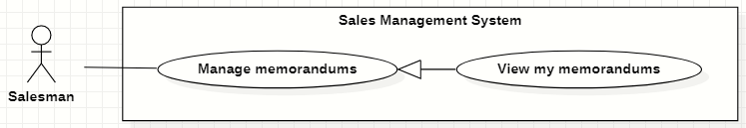

*Figure 29. <<Salesman>> View my memorandums*

|  |  |  |  |  |  |
| --- | --- | --- | --- | --- | --- |
| ID and Name: | **UC-23 View my memorandums** | | | | |
| Created By: | HaPTN | | Date Created: | | 12/04/2021 |
| Primary Actor: | Salesman | | Secondary Actors: | | N/A |
| Description: | This use case allows the user to view the list of memorandum’s of his/her assigned target schools. | | | | |
| Trigger: | The user selects tab “Memorandums” in “Target School’s details” screen. | | | | |
| Preconditions: | PRE-1. The user has been logged into the system with role Salesman, Sales Supervisor or Sales Manager.  PRE-2. The user is on the tab “Memorandums” in “Target School’s details” screen. | | | | |
| Post-conditions: | POST-1. Memorandum’s list is displayed as the table in “Memorandums” screen. | | | | |
| Normal Flow: | **Step** | **Actor Action** | | **System Response** | |
| 1 | The user selects tab “Memorandums” in “Target School’s details” screen. | | The system displays “Memorandums” screen, memorandum’s list is displayed as the table.   * “Target Schools”: text. * “Duration”: text. * “Service”: text. * “Revenue Criteria”: text. * “Note”: text. | |
| Alternative Flows: | N/A | | | | |
| Exceptions: | **No** | **Cause** | | **System Response** | |
| 1 | No stored memorandums data in the system. | | The system displays “No records found” line on the table. | |
|  | 2 | The user’s device does not connect to the Internet or the server has internal error. | | The system shows the error message: “Connection Failed or Internal Error”. | |
| Priority: | High | | | | |
| Frequency of Use: | Usually | | | | |
| Business Rules: | BR-31, BR-32, BR-34, BR-40 | | | | |
| Other Information: | N/A | | | | |
| Assumptions: | N/A | | | | |

*Table 26. <<Salesman>> View my memorandums*

#### View memorandum’s details

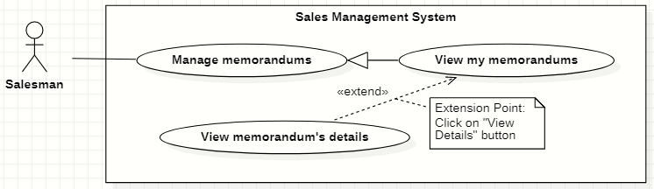

*Figure 30. <<Salesman>> View memorandum’s details*

|  |  |  |  |  |  |
| --- | --- | --- | --- | --- | --- |
| ID and Name: | **UC-24 View memorandum’s details** | | | | |
| Created By: | HaPTN | | Date Created: | | 12/04/2021 |
| Primary Actor: | Salesman | | Secondary Actors: | | N/A |
| Description: | This use case allows the user to view a memorandum’s details. | | | | |
| Trigger: | The user selects a specific memorandum in the list of memorandums in tab “Memorandums” on “Target School’s details” screen. | | | | |
| Preconditions: | PRE-1. The user has been logged into the system with role Sales Manager.  PRE-2. The user is on the tab “Memorandums” in “Target School’s details” screen. | | | | |
| Post-conditions: | POST-1. Memorandum’s details is displayed as the dialog in “Memorandums” screen. | | | | |
| Normal Flow: | **Step** | **Actor Action** | | **System Response** | |
|  | 1 | The user clicks on a specific memorandum in the list of memorandums in tab “Memorandums” on “Target School’s details” screen. | | The system displays the “Memorandum’s details” dialog with the following information:   * “ID”: text. * “Target Schools”: text. * “Duration”: text. * “Service”: text. * “Revenue Criteria”: text. * “Note”: text.   [Exception 1] | |
| Alternative Flows: | N/A | | | | |
| Exceptions: | **No** | **Cause** | | **System Response** | |
|  | 1 | The user’s device does not connect to the Internet or the server has internal error. | | The system shows the error message: “Connection Failed or Internal Error”. | |
| Priority: | Medium | | | | |
| Frequency of Use: | Usually | | | | |
| Business Rules: | BR-31, BR-32, BR-34, BR-40 | | | | |
| Other Information: | N/A | | | | |
| Assumptions: | N/A | | | | |

*Table 27. <<Salesman>> View memorandum’s details*

#### Edit my memorandums

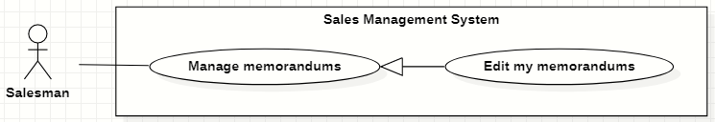

*Figure 31. <<Salesman>> Edit my memorandums*

|  |  |  |  |  |  |
| --- | --- | --- | --- | --- | --- |
| ID and Name: | **UC-25 Edit my memorandums** | | | | |
| Created By: | HaPTN | | Date Created: | | 12/04/2021 |
| Primary Actor: | Salesman | | Secondary Actors: | | N/A |
| Description: | This use case allows the user to edit the information of memorandum’s of his/her assigned target schools. | | | | |
| Trigger: | The user selects tab “Memorandums” in “Target School’s details” screen. | | | | |
| Preconditions: | PRE-1. The user has been logged into the system with role Salesman, Sales Supervisor or Sales Manager.  PRE-2. The user is on the tab “Memorandums” in “Target School’s details” screen. | | | | |
| Post-conditions: | POST-1. The detail information of this memorandum is edited in database. | | | | |
| Normal Flow: | **Step** | **Actor Action** | | **System Response** | |
| 1 | The user selects a specific row of memorandums in “Target School’s details” screen. | | The system displays “Memorandum’s detail” dialog which contains:   * “Target Schools”: text, read only. * “Duration”: input text field. * “Service”: check boxes. * “Revenue Criteria”: check boxes. * “Note”: text area. * “Cancel”: button. * “Save”: button. | |
|  | 2 | The user edits on fields in this form.  [Exception 1] | |  | |
|  | 3 | The user clicks “Save” button when finish. | | The system update new information in the database, then displays the successful message: “Updated Successfully”.  [Exception 2] | |
| Alternative Flows: | N/A | | | | |
| Exceptions: | **No** | **Cause** | | **System Response** | |
| 1 | The user inputs invalid format content into fields. | | The system informs the users that the content of fields is invalid format. | |
|  | 2 | The user’s device does not connect to the Internet or the server has internal error. | | The system shows the error message: “Connection Failed or Internal Error”. | |
| Priority: | High | | | | |
| Frequency of Use: | Usually | | | | |
| Business Rules: | BR-31, BR-32, BR-34, BR-40 | | | | |
| Other Information: | N/A | | | | |
| Assumptions: | N/A | | | | |

*Table 28. <<Salesman>> Edit my memorandums*

#### Create reports

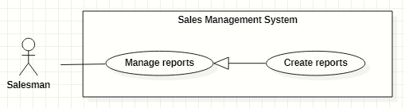

*Figure 32. <<Salesman>> Create reports*

|  |  |  |  |  |  |
| --- | --- | --- | --- | --- | --- |
| ID and Name: | **UC-26 Create reports** | | | | |
| Created By: | GiaNH | | Date Created: | | 08/02/2021 |
| Primary Actor: | Salesman | | Secondary Actors: | | N/A |
| Description: | This use case allows the user to create daily reports. | | | | |
| Trigger: | The user selects the “Create” command on “Reports” screen. | | | | |
| Preconditions: | PRE-1. The user has been logged into the system with role Salesman, Sales Supervisor or Sales Manager.  PRE-2. The user is on the “Reports” screen. | | | | |
| Post-conditions: | POST-1. A new report is created in the system. | | | | |
| Normal Flow: | **Step** | **Actor Action** | | **System Response** | |
| 1 | The user selects the “Create” button on “Reports” screen.  [Alternative] | | The system shows “Create Report” view that contains following information fields:   * “Target Schools”: input text field, required. * “Date”: date, read only, default is current date. * “Result”: input text field, required. * “Description”: input text field, required. * “Positivity”: input text field. * “Difficulty”: input text field. * “Future plan”: input text field. | |
| 2 | The user inputs the information into the required fields.  [Exception 1] | |  | |
| 3 | The user clicks on “Save” button to create a new daily report.  [Alternative 1] | | The system shows the successful message: “Created successfully”.  [Exception 2]  [Exception 3] | |
| 4 |  | | The system updates the table of list of reports in the “Reports” screen.  [Exception 2] | |
| Alternative Flows: | **Step** | **Actor Action** | | **System Response** | |
| 1 | The user clicks on “+” button to continue create daily report for another school. | | The system resets the “Create Report” form and shows the previous inputted reports in “Preview” table.  Table contains these columns:   * “School Name”: text. * “Result”: text. * “Description”: text.   *Continue to step 2 of Normal Flow*. | |
| Exceptions: | **No** | **Cause** | | **System Response** | |
| 1 | The user leaves the blank fields or inputs invalid format content. | | The system shows the error message: “Please input the valid format content”. | |
| 2 | The user’s device does not connect to the Internet or the server has internal error. | | The system shows the error message: “Connection Failed or Internal Error”. | |
| 3 | The user selects “Cancel” button. | | The system closes the “Create Report” view and returns the Reports screen. | |
| Priority: | High | | | | |
| Frequency of Use: | Usually | | | | |
| Business Rules: | BR-21, BR-22, BR-23, BR-24, BR-40 | | | | |
| Other Information: | N/A | | | | |
| Assumptions: | N/A | | | | |

*Table 29. <<Salesman>> Create reports*

#### Search reports

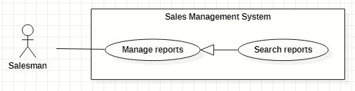

*Figure 33. <<Salesman>> Search reports*

|  |  |  |  |  |  |
| --- | --- | --- | --- | --- | --- |
| ID and Name: | **UC-27 Search reports** | | | | |
| Created By: | HaPTN | | Date Created: | | 09/02/2021 |
| Primary Actor: | Salesman | | Secondary Actors: | | N/A |
| Description: | This use case allows the user to find the reports based on target school’s name, district, PIC’s name, from date to date,…. | | | | |
| Trigger: | The user selects on the searching command on “Reports” screen. | | | | |
| Preconditions: | PRE-1. The user has been logged into the system with role Salesman, Sales Supervisor or Sales Manager.  PRE-2. The user is on the “Reports” screen. | | | | |
| Post-conditions: | POST-1. The list of reports is displayed as the table. | | | | |
| Normal Flow: | **Step** | **Actor Action** | | **System Response** | |
| 1 | The user inputs the search field or select searching filters on toolbar to find reports. | | The system displays the list of reports as the table.  Available filters on this screen:  “PICs”: selections (all salesmen in the Sales Department)   * “Districts”: selections (24 districts in Ho Chi Minh City) * “School Years”: selections (2020-2021, 2019-2020, 2018-2019,…). * “From date” – “To date”: date range picker, disable future days. * “School Statuses”: selections (Leads, Customer, Ngưng hợp tác). * “Purposes”: selections (   - Leads: Sales mới, Theo dõi;  - Customer: Chăm sóc, Tái ký hợp đồng, Ký mới hợp đồng;  - Ngưng hợp tác  )   * Search field: text field. | |
|  | 2 |  | | The system displays the list of target schools as a table.   * “Date”: date. * “School Name”: text. * “PIC”: image (avatar) and text. * “Purpose”: Label. * “Result”: text. * “Description”: text.   [Exception 1]  [Exception 2] | |
| Alternative Flows: | N/A | | | | |
| Exceptions: | **No** | **Cause** | | **System Response** | |
| 1 | The content of search field or selecting filter that The user inputted is not matched any stored data in the system. | | The system displays “No records found” line on the table. | |
| 2 | The user’s device does not connect to the Internet or the server has internal error. | | The system shows the error message: “Connection Failed or Internal Error”. | |
| Priority: | Medium | | | | |
| Frequency of Use: | Usually | | | | |
| Business Rules: | * BR-20, BR-24, BR-39, BR-40 * The default values of all filters are “All”. | | | | |
| Other Information: | N/A | | | | |
| Assumptions: | N/A | | | | |

*Table 30. <<Salesman>> Search reports*

#### View all reports

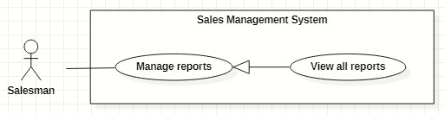

*Figure 34. <<Salesman>> View all reports*

|  |  |  |  |  |  |
| --- | --- | --- | --- | --- | --- |
| ID and Name: | **UC-28 View all reports** | | | | |
| Created By: | GiaNH | | Date Created: | | 08/02/2021 |
| Primary Actor: | Salesman | | Secondary Actors: | | N/A |
| Description: | This use case allows the user to view list of all daily report’s of all members in Major Sales Department. | | | | |
| Trigger: | The user selects “Reports” on the navigation bar (sidebar). | | | | |
| Preconditions: | PRE-1. The user has been logged into the system with role Salesman, Sales Supervisor or Sales Manager. | | | | |
| Post-conditions: | POST-1. Report’s list is displayed as the table in “Reports” screen. | | | | |
| Normal Flow: | **Step** | **Actor Action** | | **System Response** | |
| 1 | The user selects “Reports” on the navigation bar (sidebar). | | The system displays “Reports” screen, report’s list is displayed as the table.   * “Date”: date. * “School Name”: text. * “PIC”: image (avatar) and text. * “Purpose”: label. * “Result”: text. * “Description”: text.   Available filters on this screen:  “PICs”: selections (all salesmen in the Sales Department)   * “Districts”: selections (24 districts in Ho Chi Minh City) * “School Years”: selections (2020-2021, 2019-2020, 2018-2019,…). * “From date” – “To date”: date range picker, disable future days. * “School Statuses”: selections (Leads, Customer, Ngưng hợp tác). * “Purposes”: selections (   - Leads: Sales mới, Theo dõi;  - Customer: Chăm sóc, Tái ký hợp đồng, Ký mới hợp đồng;  - Ngưng hợp tác  )   * Search field: text field.   [Exception 1]  [Exception 2] | |
| Alternative Flows: | N/A | | | | |
| Exceptions: | **No** | **Cause** | | **System Response** | |
| 1 | No stored reports data in the system. | | The system displays “No records found” line on the table. | |
|  | 2 | The user’s device does not connect to the Internet or the server has internal error. | | The system shows the error message: “Connection Failed or Internal Error”. | |
| Priority: | High | | | | |
| Frequency of Use: | Usually | | | | |
| Business Rules: | BR-20, BR-24, BR-39, BR-40 | | | | |
| Other Information: | N/A | | | | |
| Assumptions: | N/A | | | | |

*Table 31. <<Salesman>> View all reports*

#### View report’s details

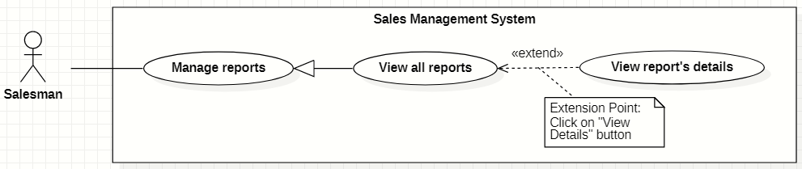

*Figure 35. <<Salesman>> View report’s details*

|  |  |  |  |  |  |
| --- | --- | --- | --- | --- | --- |
| ID and Name: | **UC-29 View report’s details** | | | | |
| Created By: | HaPTN | | Date Created: | | 12/04/2021 |
| Primary Actor: | Salesman | | Secondary Actors: | | N/A |
| Description: | This use case allows the user to view the detail information of a report. | | | | |
| Trigger: | The user clicks on the “View details” command on the menu options at the end of row in table list of reports. | | | | |
| Preconditions: | PRE-1. The user has been logged into the system with role Salesman, Sales Supervisor or Sales Manager.  PRE-2. The user is on the “Reports” screen. | | | | |
| Post-conditions: | POST-1. The detail information of report is shown as a form. | | | | |
| Normal Flow: | **Step** | **Actor Action** | | **System Response** | |
| 1 | On the “Reports” screen, at the end of each row in the table, the user clicks on action icon button, then selects “View detail” command on the menu options. | | The system displays “Report’s details” view, the report’s information is displayed as a form.   * “School Year”: text. * “Date”: text. * “School Name”: text. * “PIC”: image (avatar) and text. * “Purpose”: text. * “Result”: input text field, required. * “Description”: input text field, required. * “Positivity”: input text field. * “Difficulty”: input text field. * “Future plan”: input text field. * “Supervisor comment”: input text field, read only. * “Save”: button, inactive.   [Exception 1] | |
| Alternative Flows: | N/A | | | | |
| Exceptions: | **No** | **Cause** | | **System Response** | |
| 1 | The user’s device does not connect to the Internet or the server has internal error. | | The system shows the error message: “Connection Failed or Internal Error”. | |
| Priority: | Medium | | | | |
| Frequency of Use: | Usually | | | | |
| Business Rules: | BR-20, BR-24, BR-39, BR-40 | | | | |
| Other Information: | N/A | | | | |
| Assumptions: | N/A | | | | |

*Table 32. <<Salesman>> View report’s details*

#### Edit reports

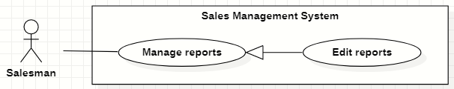

*Figure 36. <<Salesman>> Edit reports*

|  |  |  |  |  |  |
| --- | --- | --- | --- | --- | --- |
| ID and Name: | **UC-30 Edit reports** | | | | |
| Created By: | HaPTN | | Date Created: | | 12/04/2021 |
| Primary Actor: | Salesman | | Secondary Actors: | | N/A |
| Description: | This use case allows the user to edit a daily report. | | | | |
| Trigger: | The user edits on fields in “Report’s details” screen then clicks “Save” button. | | | | |
| Preconditions: | PRE-1. The user has been logged into the system with role Salesman, Sales Supervisor or Sales Manager.  PRE-2. The user is on the “Report’s details” screen. | | | | |
| Post-conditions: | POST-1. A new report is updated in the database. | | | | |
| Normal Flow: | **Step** | **Actor Action** | | **System Response** | |
| 1 | The user edits on fields in “Report’s details” screen then clicks “Save” button. | | The system displays “Report’s details” view, the report’s information is displayed as a form.   * “School Year”: text. * “Date”: text. * “School Name”: text. * “PIC”: image (avatar) and text. * “Purpose”: text. * “Result”: input text field, required. * “Description”: input text field, required. * “Positivity”: input text field. * “Difficulty”: input text field. * “Future plan”: input text field. * “Supervisor comment”: input text field, read only. * “Save”: button, only active when the form is dirty. | |
| 2 | The user edits on fields in this form.  [Exception 1] | |  | |
| 3 | The user clicks “Save” button when finish. | | The system has successful edit and displays the successful message: “Updated Successfully”.  [Exception 2] | |
| Alternative Flows: | N/A | | | | |
| Exceptions: | **No** | **Cause** | | **System Response** | |
| 1 | The user inputs invalid format content into fields. | | The system informs the users that the content of fields is invalid format. | |
|  | 2 | The user’s device does not connect to the Internet or the server has internal error. | | The system shows the error message: “Connection Failed or Internal Error”. | |
| Priority: | High | | | | |
| Frequency of Use: | Usually | | | | |
| Business Rules: | * BR-24, BR-28, BR-29, BR-30, BR-39, BR-40 * The user can only edit reports which have not been commented by the supervisor or the manager. | | | | |
| Other Information: | N/A | | | | |
| Assumptions: | N/A | | | | |

*Table 33. <<Salesman>> Edit reports*

#### Remove reports

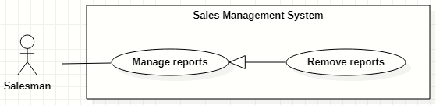

*Figure 37. <<Salesman>> Remove reports*

|  |  |  |  |  |  |
| --- | --- | --- | --- | --- | --- |
| ID and Name: | **UC-31 Remove reports** | | | | |
| Created By: | HaPTN | | Date Created: | | 12/04/2021 |
| Primary Actor: | Salesman | | Secondary Actors: | | N/A |
| Description: | This use case allows the user to remove a daily report. | | | | |
| Trigger: | The user clicks on the “Remove” command on the menu options at the end of row in table list of reports. | | | | |
| Preconditions: | PRE-1. The user has been logged into the system with role Salesman, Sales Supervisor or Sales Manager.  PRE-2. The user is on the “Reports” screen. | | | | |
| Post-conditions: | POST-1. A daily report is removed in the database. | | | | |
| Normal Flow: | **Step** | **Actor Action** | | **System Response** | |
|  | 1 | The user clicks on the “Remove” command on the menu options at the end of row in table list of reports. | | The system shows a “Confirm Remove” dialog to alert.   * “Cancel”: button. * “Remove”: button. | |
|  | 2 | The user clicks on “Remove” button.  [Exception 1] | | The system shows a successful message: “Removed successfully”, and closes the confirm dialog. | |
| Alternative Flows: | N/A | | | | |
| Exceptions: | **No** | **Cause** | | **System Response** | |
| 1 | The user selects “Cancel” button. | | The system closes the “Confirm Remove” dialog and returns the Reports screen. | |
| 2 | The user’s device does not connect to the Internet or the server has internal error. | | The system shows the error message: “Connection Failed or Internal Error”. | |
| Priority: | High | | | | |
| Frequency of Use: | Sometimes | | | | |
| Business Rules: | * BR-28, BR-29, BR-40 * The user can only edit reports The user can only remove reports which have not been commented by the supervisor or the manager. | | | | |
| Other Information: | N/A | | | | |
| Assumptions: | N/A | | | | |

*Table 34 <<Salesman>> Remove reports*

#### Create personal activities

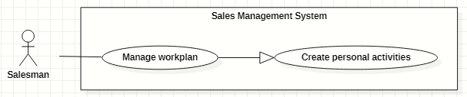

*Figure 38. <<Salesman>> Create personal activities*

|  |  |  |  |  |  |  |  |
| --- | --- | --- | --- | --- | --- | --- | --- |
| ID and Name: | **UC-32 Create personal activities** | | | | | | |
| Created By: | GiaNH, HaPTN | | | | Date Created: | | 12/04/2021 |
| Primary Actor: | Salesman, Sales Supervisor, Sales Manager | | | | Secondary Actors: | | N/A |
| Description: | This use case allows the user to create one or multiple personal activities in his/her workplan. | | | | | | |
| Trigger: | The user wants to create one or multiple personal activities. | | | | | | |
| Preconditions: | PRE-1. The user has been logged into the system with role Salesman, Sales Supervisor or Sales Manager.  PRE-2. The user is on the “Work-plan” screen. | | | | | | |
| Post-conditions: | POST-1. New personal activity/personal activities is/are added in work-plan schedule. | | | | | | |
| Normal Flow: | **Step** | | **Actor Action** | | | **System Response** | |
| 1 | | The user clicks on a cell and chooses “More details” button on the “Work-plan” screen.  [Alternative 1] | | | The system displays the “Add Activity” form dialog that contains the following format fields:   * “Title”: text, required. * “Location”: text. * “Description”: text. * “Remark”: text. * “Start time”: date time, required. * “End time”: date time, required. * “isAllDay”:check box [True- False] , default is “False”. * “Repeat”: selection (Never, Daily, Weekly, Monthly, Yearly), default is “Never”. * “isCompleted”: check box [True, False], defalt is False. * “Cancel”: button. * “Save”: button. | |
| 2 | | The user inputs into the information fields.  [Exception 1]  [Alternative 2] | | |  | |
| 3 | | The user selects the “Save” button. | | | The system creates new activity in the database and update the “Work-plan” screen.  [Exception 2] | |
| Alternative Flows: | No | **Step** | | **Actor Action** | | **System Response** | |
| 1 | 1 | | The user clicks on a cell and on the “Work-plan” screen. | | The system shows a quick create dialog which contains:   * “Title”: text, required. * “Time”: text, read only. * “More details”: button. * “Save”: button. | |
| 2 | | The user selects the “Save” button. | | The system creates new activity in the database and update the “Work-plan” screen.  [Exception 2] | |
| 2 | 1 | | The user selects other options (Daily, Weekly, Monthly, Yearly). | | The system shows relative option’s details for each case. | |
| 2 | | The user selects the “Save” button. | | The system creates a serie of activities in the database and update the “Work-plan” screen.  [Exception 2] | |
| Exceptions: | **No** | | **Actor Action** | | | **System Response** | |
| 1 | | The user leaves the blank fields or inputs invalid format content into fields. | | | The system shows the error message: “Please input the valid format content”. | |
| 2 | | The user’s device does not connect to the Internet or the server has internal error. | | | The system shows the error message: “Connection Failed or Internal Error”. | |
| Priority: | Normal | | | | | | |
| Frequency of Use: | Usually | | | | | | |
| Business Rules: | BR-35, BR-36, BR-37, BR-38, BR-40 | | | | | | |
| Other Information: | N/A | | | | | | |
| Assumptions: | N/A | | | | | | |

*Table 35. <<Salesman>> Create personal activities*

#### Search other’s workplan

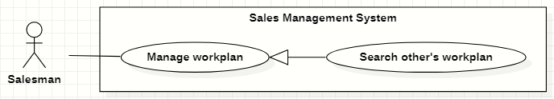

*Figure 39. <<Salesman>> Search other’s workplan*

|  |  |  |  |  |  |
| --- | --- | --- | --- | --- | --- |
| ID and Name: | **UC-33 Search other’s workplan** | | | | |
| Created By: | GiaNH, HaPTN | | Date Created: | | 12/04/2021 |
| Primary Actor: | Salesman, Sales Supervisor, Sales Manager | | Secondary Actors: | | N/A |
| Description: | This use case allows the user to search the work-plan of other users. | | | | |
| Trigger: | The user input in the search field on “Work-plan” screen. | | | | |
| Preconditions: | PRE-1. The user has been logged into the system with role Salesman, Sales Supervisor or Sales Manager.  PRE-2. The user is on the “Work plan” screen. | | | | |
| Post-conditions: | POST-1. The work plan schedule is displayed on the screen. | | | | |
| Normal Flow: | **Step** | **Actor Action** | | **System Response** | |
| 1 | On the “Work plan” screen, the user inputs into the search field username or full name of people he/she wants to view the work-plan. | | The system provides suggestions that presents Salesman to users as they enter their search query into the search box. | |
|  | 2 | The user selects a Salesman item in suggestions. | | The system displays “work-plan” screen. The Work-plan has the personal activity items that present as a schedule. | |
| Alternative Flows: | N/A | | | | |
| Exceptions: | **No** | **Actor Action** | | **System Response** | |
| 1 | The content of search field or selecting filter that the user inputted is not matched any stored data in the system. | | The system displays “No records found” line on the table. | |
|  | 2 | The user’s device does not connect to the Internet or the server has internal error. | | The system shows the error message: “Connection Failed or Internal Error”. | |
| Priority: | Normal | | | | |
| Frequency of Use: | Usually | | | | |
| Business Rules: | * BR-35, BR-39, BR-40 * The Sales Manager can view the Salesman’s work-plan and other Sales Manager’s work-plan. * The Salesman can only view the work-plan of other Salesman. * The user is not allowed to create/edit/remove anything in other person’s work-plan. | | | | |
| Other Information: | N/A | | | | |
| Assumptions: | N/A | | | | |

*Table 36. <<Salesman>> Search other’s workplan*

#### View workplan

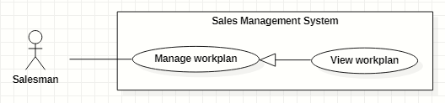

*Figure 40. <<Salesman>> View workplan*

|  |  |  |  |  |  |
| --- | --- | --- | --- | --- | --- |
| ID and Name: | **UC-34 View workplan** | | | | |
| Created By: | GiaNH, HaPTN | | Date Created: | | 12/04/2021 |
| Primary Actor: | Salesman, Sales Supervisor, Sales Manager | | Secondary Actors: | | N/A |
| Description: | This use case allows the user to view a whole workplan of himself/herself or other’s. | | | | |
| Trigger: | The user selects “Workplans” on the navigation bar (sidebar). | | | | |
| Preconditions: | PRE-1. The user has been logged into the system with role Salesman, Sales Supervisor or Sales Manager. | | | | |
| Post-conditions: | POST-1. The personal activities are displayed in workplan schedule. | | | | |
| Normal Flow: | **Step** | **Actor Action** | | **System Response** | |
| 1 | The user selects “Workplans” on the navigation bar (sidebar). | | The system displays “work-plan” screen. The Work-plan has the personal activity items that present as a schedule  [Exception 1] | |
| Alternative Flows: | N/A | | | | |
| Exceptions: | **No** | **Cause** | | **System Response** | |
| 1 | The user’s device does not connect to the Internet or the server has internal error. | | The system shows the error message: “Connection Failed or Internal Error”. | |
| Priority: | Normal | | | | |
| Frequency of Use: | Usually | | | | |
| Business Rules: | * BR-35, BR-39, BR-40 * The system displays the “Work-plan” as a week’s schedule with the activity item is a cell in the schedule. * The activity items have different colors to distinguish based on status. * The users can view the Work-plan by Day, Week, Month. | | | | |
| Other Information: | N/A | | | | |
| Assumptions: | N/A | | | | |

*Table 37. <<Salesman>> View workplan*

#### View personal activity’s details

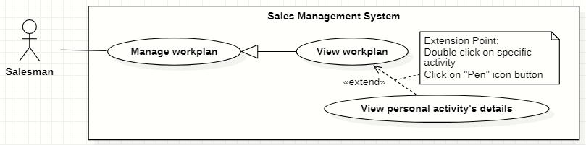

*Figure 41. <<Salesman>> View personal activity’s details*

|  |  |  |  |  |  |
| --- | --- | --- | --- | --- | --- |
| ID and Name: | **UC-35 View personal activity’s details** | | | | |
| Created By: | GiaNH, HaPTN | | Date Created: | | 12/04/2021 |
| Primary Actor: | Salesman, Sales Supervisor, Sales Manager | | Secondary Actors: | | N/A |
| Description: | This use case allows the user to view the detail information of personal activity. | | | | |
| Trigger: | The user clicks on the personal activity item on work-plan screen. | | | | |
| Preconditions: | PRE-1. The user has been logged into the system with role Salesman, Sales Supervisor or Sales Manager.  PRE-2. The user is on the “Work-plan” screen. | | | | |
| Post-conditions: | POST-1. The detail information of personal activity is shown as a form. | | | | |
| Normal Flow: | **Step** | **Actor Action** | | **System Response** | |
| 1 | The user clicks on an item and chooses “pen” icon button on the “Work-plan” screen.  [Alternative 1] | | *If the user is viewing his/her own work-plan*:  The system displays the “Activity’s details” form dialog that contains the following format fields:   * “Title”: text, required. * “Location”: text. * “Description”: text. * “Remark”: text. * “Start time”: date time, required. * “End time”: date time, required. * “isAllDay”:check box [True- False] , default is “False”. * “Repeat”: selection (Never, Daily, Weekly, Monthly, Yearly), default is “Never”. * “isCompleted”: check box [True, False], defalt is False.   ----------  *If the user is viewing other’s work-plan*:  The system displays the “Activity’s details” quick dialog that contains:   * “Title”: text. * “Location”: text. * “Description”: text. * “Time”: text (including start time and end time). * “isCompleted” is displayed by different colors. | |
| Alternative Flows: | **Step** | **Actor Action** | | **System Response** | |
| 1 | The user double clicks on an item on the “Work-plan” screen. | | The system displays the “Activity’s details” quick dialog that contains the following format fields:   * “Title”: text, required. * “Location”: text. * “Description”: text. * “Time”: text (including start time and end time). * “isCompleted” is displayed by different colors. | |
| Exceptions: | **No** | **Actor Action** | | **System Response** | |
| 1 | The user’s device does not connect to the Internet or the server has internal error. | | The system shows the error message: “Connection Failed or Internal Error”. | |
| Priority: | Normal | | | | |
| Frequency of Use: | Usually | | | | |
| Business Rules: | BR-35, BR-39, BR-40 | | | | |
| Other Information: | N/A | | | | |
| Assumptions: | N/A | | | | |

*Table 38. <<Salesman>> View personal activity’s details*

#### Edit personal activities

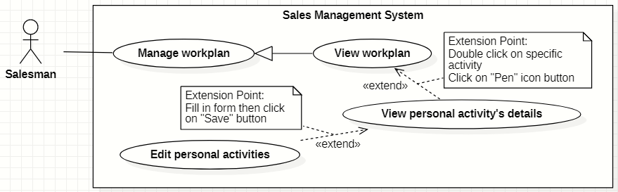

*Figure 42. <<Salesman>> Edit personal activities*

|  |  |  |  |  |  |
| --- | --- | --- | --- | --- | --- |
| ID and Name: | **UC-36 Edit personal activities** | | | | |
| Created By: | GiaNH, HaPTN | | Date Created: | | 12/04/2021 |
| Primary Actor: | Salesman, Sales Supervisor, Sales Manager | | Secondary Actors: | | N/A |
| Description: | This use case allows the user to edit personal activities in his/her workplan. | | | | |
| Trigger: | The user wants to edit one or multiple personal activities. | | | | |
| Preconditions: | PRE-1. The user has been logged into the system with role Salesman, Sales Supervisor or Sales Manager.  PRE-2.1. The user is on the “Workplan” screen. | | | | |
| Post-conditions: | POST-1. The personal activity/personal activities is/are updated in the database. | | | | |
| Normal Flow: | **Step** | **Actor Action** | | **System Response** | |
| 1 | The user clicks on an item and chooses “pen” icon button on the “Work-plan” screen.  [Alternative 1] | | The system displays the “Edit Activity” form dialog that contains the following format fields:   * “Title”: text, required. * “Location”: text. * “Description”: text. * “Remark”: text. * “Start time”: date time, required. * “End time”: date time, required. * “isAllDay”:check box [True- False] , default is “False”. * “Repeat”: selection (Never, Daily, Weekly, Monthly, Yearly), default is “Never”. * “isCompleted”: check box [True, False], defalt is False. * “Cancel”: button. * “Save”: button. * “Delete”: button. | |
| 2 | The user inputs the new content in the fields. | |  | |
| 3 | The user clicks “Save” button.  [Exception 1] | | The system update “Work-plan” screen with new data.  [Exception 2] | |
| Alternative Flows: | **Step** | **Actor Action** | | **System Response** | |
| 1 | The user double clicks on an item on the “Work-plan” screen. | | The system shows the dialog “Edit event” for the use to choose whether edit an activity or edit the entire series. | |
| 2 |  | | The system displays the “Edit Activity” form dialog that contains the following format fields:   * “Title”: text, required. * “Location”: text. * “Description”: text. * “Remark”: text. * “Start time”: date time, required. * “End time”: date time, required. * “isAllDay”:check box [True- False] , default is “False”. * “Repeat”: selection (Never, Daily, Weekly, Monthly, Yearly), default is “Never”. * “isCompleted”: check box [True, False], defalt is False. * “Cancel”: button. * “Save”: button. * “Delete”: button.   *Continue to step 2 in the Normal Flow.* | |
| Exceptions: | **No** | **Actor Action** | | **System Response** | |
| 1 | The user selects “Cancel” button to cancel the editing. | | The system discards all changes and close the “Edit Activity” dialog. | |
| 2 | The user’s device does not connect to the Internet or the server has internal error. | | The system shows the error message: “Connection Failed or Internal Error”. | |
| Priority: | Normal | | | | |
| Frequency of Use: | Usually | | | | |
| Business Rules: | BR-35, BR-36, BR-38, BR-39, BR-40 | | | | |
| Other Information: | N/A | | | | |
| Assumptions: | N/A | | | | |

*Table 39. <<Salesman>> Edit personal activities*

#### Remove personal activities

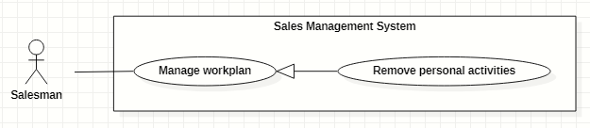

*Figure 43. <<Salesman>> Remove personal activities*

|  |  |  |  |  |  |
| --- | --- | --- | --- | --- | --- |
| ID and Name: | **UC-37 Remove personal activities** | | | | |
| Created By: | GiaNH, HaPTN | | Date Created: | | 12/04/2021 |
| Primary Actor: | Salesman, Sales Supervisor, Sales Manager | | Secondary Actors: | | N/A |
| Description: | This use case allows the user to remove personal activities in his/her workplan. | | | | |
| Trigger: | The user wants to remove one or multiple personal activities. | | | | |
| Preconditions: | PRE-1. The user has been logged into the system with role Salesman, Sales Supervisor or Sales Manager.  PRE-2.1. The user is on the “Workplan” screen. | | | | |
| Post-conditions: | POST-1. The personal activity/personal activities is/are removed in the database. | | | | |
| Normal Flow: | **Step** | **Actor Action** | | **System Response** | |
| 1 | On the “Work-plan” screen, the user clicks on an item and selects “Remove” icon button in the quick view pop-up.  [Alternative 1] | | The system shows the dialog “Delete Activity” for the use to choose whether remove an activity or remove the entire series. | |
| 2 | The user selects a button to confirm the removing.  [Exception 1] | | The system update “Work-plan” screen with new data.  [Exception 2] | |
| Alternative Flows: | **Step** | **Actor Action** | | **System Response** | |
| 1 | The user double clicks on an item on the “Work-plan” screen. | | The system displays the “Edit Activity” form dialog that contains the following format fields:   * “Title”: text, required. * “Location”: text. * “Description”: text. * “Remark”: text. * “Start time”: date time, required. * “End time”: date time, required. * “isAllDay”:check box [True- False] , default is “False”. * “Repeat”: selection (Never, Daily, Weekly, Monthly, Yearly), default is “Never”. * “isCompleted”: check box [True, False], defalt is False. * “Cancel”: button. * “Save”: button. * “Delete”: button. | |
|  | 2 | The user clicks on “Delete” button.  [Exception 1] | | The system shows confirmation dialog “Delete Activity” which includes:   * “Delete”: button. * “Cancel”: button. | |
|  | 3 | The user clicks on “Delete” button.  [Exception 1] | | The system update “Work-plan” screen with new data.  [Exception 2] | |
| Exceptions: | **No** | **Actor Action** | | **System Response** | |
| 1 | The user selects “Cancel” button to cancel the removing. | | The system returns the “Work-plan” screen. | |
|  | 2 | The user’s device does not connect to the Internet or the server has internal error. | | The system shows the error message: “Connection Failed or Internal Error”. | |
| Priority: | Normal. | | | | |
| Frequency of Use: | Usually | | | | |
| Business Rules: | BR-35, BR-36, BR-39, BR-40 | | | | |
| Other Information: | N/A | | | | |
| Assumptions: | N/A | | | | |

*Table 40. <<Salesman>> Remove personal activities*

### 2.6 <<Sales Supervisor>> Overview Use Case

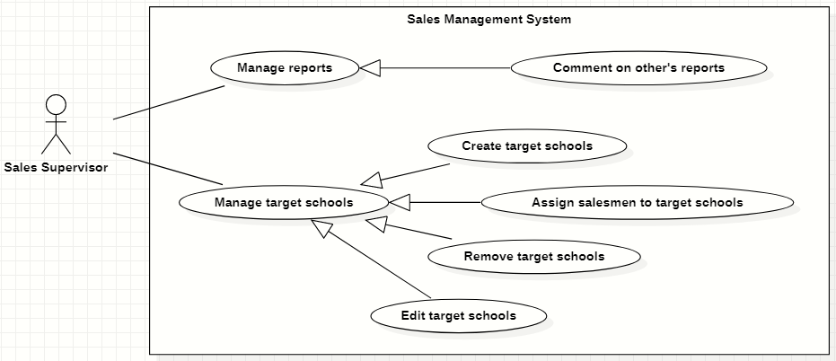

*Figure 44. <<Sales Supervisor>> Overview Use Case*

#### Create target schools

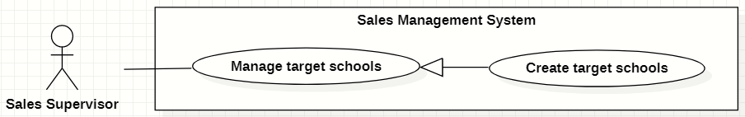

*Figure 45. <<Sales Supervisor>> Create target schools*

|  |  |  |  |  |  |
| --- | --- | --- | --- | --- | --- |
| ID and Name: | **UC-38 Create target schools** | | | | |
| Created By: | GiaNH, HaPTN | | | Date Created: | 15/02/2021 |
| Primary Actor: | Sales Supervisor, Sales Manager | | | Secondary Actors: | N/A |
| Description: | This use case allows the user to create new target schools from the list of all schools. | | | | |
| Trigger: | The user clicks on the “Create” button on “Target Schools” screen. | | | | |
| Preconditions: | PRE-1. The user has been logged into the system with role Sales Supervisor or Sales Manager.  PRE-2. The user is on the “Target Schools” screen. | | | | |
| Post-conditions: | POST-1. The new target schools are created in the system. | | | | |
| Normal Flow: | **Step** | **Actor Action** | **System Response** | | |
| 1 | The user clicks on the “Create” button on “Target Schools” screen. | The system displays the “Create Target School” form with following required information:   * “School year”: text, default is the current school year, read only. * A table of all schools which has the following columns: * “”: checkbox. * “School Name”: text. * “Principal”: text. * “School Status”: text. * “Purpose”: selections (   - Leads: Sales mới, Theo dõi;  - Customer: Chăm sóc, Tái ký hợp đồng, Ký mới hợp đồng;  - Ngưng hợp tác  ) (value of purpose depends on value of “School Status”), required.   * “Note”: text. * Preview panel: div (to display school’s details). * “Cancel”: button. * “Save”: button. | | |
| 2 | The user ticks the check boxes and chooses “Purpose” in the selections.  [Alternative 1] |  | | |
| 3 | The user selects “Save” button.  [Exception 2] | The system shows the successful message: “Created successfully”.  [Exception 1] | | |
| 4 |  | The system updates the table of list of target schools in the “Target Schools” screen.  [Exception 1] | | |
| Alternative Flows: | **Step** | **Actor Action** | **System Response** | | |
| 1 | The users clicks on a table row. | The systems display that school’s details in the preview panel.   * “School Name”: text. * “School level”: text. * “School type”: text. * “School scale”: text. * “School status”: text. * “Address”: text. * “School phone”: text. * “Representative name”: text. * “Representative phone”: text. * “Representative email”: text. * “Representative isMale”: text. * “This school also be targeted in”: text, list of school year.   *Continue to step 2 of Normal Flow*. | | |
| Exceptions: | **No** | **Cause** | **System Response** | | |
| 1 | The user’s device does not connect to the Internet or the server has internal error. | The system shows the error message: “Connection Failed or Internal Error”. | | |
| 2 | The user selects “Cancel” button. | The system closes the “Create Target Schools” form and returns to the “Target Schools” screen. | | |
| Priority: | High | | | | |
| Frequency of Use: | Usually | | | | |
| Business Rules: | * BR-11, BR-12, BR-13 * Sales Supervisor/Sales Manager can only create the target schools at the current school year. | | | | |
| Other Information: | N/A | | | | |
| Assumptions: | N/A | | | | |
| Assumptions: | N/A | | | | |

*Table 41. <<Sales Supervisor>> Create target schools*

#### Edit target schools

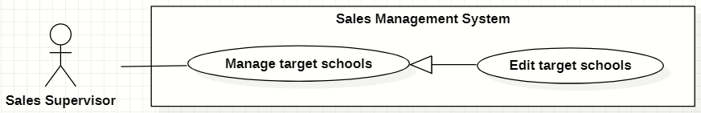

*Figure 46. <<Sales Supervisor>> Edit target schools*

|  |  |  |  |  |  |
| --- | --- | --- | --- | --- | --- |
| ID and Name: | **UC-39 Edit target schools** | | | | |
| Created By: | HaPTN | | Date Created: | | 12/04/2021 |
| Primary Actor: | Sales Supervisor, Sales Manager | | Secondary Actors: | | N/A |
| Description: | This use case allows the user to edit a target school. | | | | |
| Trigger: | The user edits on fields in “Target School’s details” screen then clicks “Save” button. | | | | |
| Preconditions: | PRE-1. The user has been logged into the system with role Sales Supervisor or Sales Manager.  PRE-2. The user is on the tab “Assign Info” in “Target School’s details” screen. | | | | |
| Post-conditions: | POST-1. The detail information of target school is edited in database. | | | | |
| Normal Flow: | **Step** | **Actor Action** | | **System Response** | |
|  | 1 | The user edits on fields in “Target School’s details” screen then clicks “Save” button. | | The system displays the “Target School’s detail” screen, on the tab “Assign Info”, there is a form with the following information:   * “School year”: text. * “PIC”: input text field, read only. * “PIC’s phone”: input text field, disabled. * “PIC’s email”: input text field, disabled. * “Purpose”: label. * “Note”: input text field. | |
|  | 2 | The user edits on fields in this form.  [Exception 1] | |  | |
|  | 3 | The user clicks “Save” button when finish. | | The system has successful edit and displays the successful message: “Updated Successfully”.  [Exception 2] | |
| Alternative Flows: | N/A | | | | |
| Exceptions: | **No** | **Cause** | | **System Response** | |
| 1 | The user inputs invalid format content into fields. | | The system informs the users that the content of fields is invalid format. | |
| 2 | The user’s device does not connect to the Internet or the server has internal error. | | The system shows the error message: “Connection Failed or Internal Error”. | |
| Priority: | Normal | | | | |
| Frequency of Use: | Usually | | | | |
| Business Rules: | * BR-12, BR-13 * The user can only edit fields: note. * To change PIC, the user needs to unsiaggn the current PIC and then assign a new PIC. | | | | |
| Other Information: | N/A | | | | |
| Assumptions: | N/A | | | | |

*Table 42. <<Sales Supervisor>> Edit target schools*

#### Assign salesmen to target schools

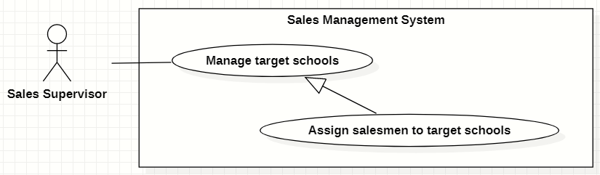

*Figure 47. <<Sales Supervisor>> Assign salesmen to target schools*

|  |  |  |  |  |  |
| --- | --- | --- | --- | --- | --- |
| ID and Name: | **UC-40 Assign salesmen to target schools** | | | | |
| Created By: | GiaNH | | Date Created: | | 11/02/2021 |
| Primary Actor: | Sales Supervisor, Sales Manager | | Secondary Actors: | | N/A |
| Description: | This use case allows the user to assign salesmen to one or multiple target schools. | | | | |
| Trigger: | The user clicks on the “Assign” button in “Target schools” screen. | | | | |
| Preconditions: | PRE-1. The user has been logged into the system with role Sales Supervisor or Sales Manager.  PRE-2. The user is on the “Target Schools” screen. | | | | |
| Post-conditions: | POST-1. The target schools are assigned to salesmen. | | | | |
| Normal Flow: | **Step** | **Actor Action** | | **System Response** | |
| 1 | The user ticks on the target school rows that he/she wants to assign, then clicks on “Assign” button on the “Target Schools” screen.  [Exception 1]  [Alternative 1] | | The system displays the “Assign Salesmen” form with the following information:   * + “PICs”: input text field, required.   + Table of target schools, which contains columns: * “School Name”: text. * “PIC”: text (get value from “PICs” input text field above). * “Purpose”: text. * “Note”: input text field / editable table cell.   + “Cancel”: button.   + “Save”: button. | |
| 2 | The user inputs/chooses a PIC in the input text field and inputs “Note”. | |  | |
| 3 | The user selects “Save” button.  [Exception 4] | | The system updates target schools’ data with field “PIC”, then shows the successful message: “Updated Successfully”.  [Exception 2]  [Exception 3] | |
| Alternative Flows: | **Step** | **Actor Action** | | **System Response** | |
| 1 | On the “Target Schools” screen, at the end of each row in the table, the user clicks on action icon button, then selects “Assign” command on the menu options. | | The system displays the “Assign” form with the following information:  -“Salesman”: input text field, required.  - “Note”: input text field.  *Continue step 2 of Normal Flow* | |
| Exceptions: | **No** | **Cause** | | **System Response** | |
| 1 | The user selects the target schools which have already been assigned. | | The system shows an alert dialog to state that “The school *[…school name]* is assigned already. If you want to assign to a new PIC, you need to unassign before assigning again.” | |
| 2 | The target school has been already assigned in the same school year. | | The system shows the error message: “The target school has been already assigned in the same school year”. | |
| 3 | The user’s device does not connect to the Internet or the server has internal error. | | The system shows the error message: “Connection Failed or Internal Error”. | |
| 4 | The user selects “Cancel” button. | | The system closes the “Assign” form and returns the “Target School” screen. | |
| Priority: | Usually | | | | |
| Frequency of Use: | N/A | | | | |
| Business Rules: | BR-12, BR-13, BR-14, BR-15, BR-16, BR-17, BR-18 | | | | |
| Other Information: | N/A | | | | |
| Assumptions: | N/A | | | | |

*Table 43. <<Sales Supervisor>> Assign salesmen to target schools*

#### Remove target schools

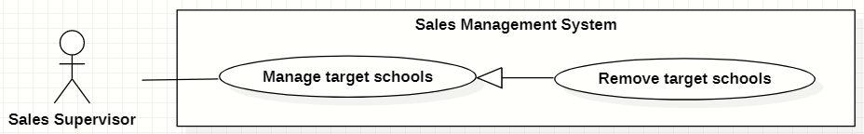

*Figure 48. <<Sales Supervisor>> Remove target schools*

|  |  |  |  |  |  |
| --- | --- | --- | --- | --- | --- |
| ID and Name: | **UC-41 Remove target schools** | | | | |
| Created By: | GiaNH | | Date Created: | | 15/02/2021 |
| Primary Actor: | Sales Supervisor, Sales Manager | | Secondary Actors: | | N/A |
| Description: | This use case allows the user to remove a target school. | | | | |
| Trigger: | The user clicks on the “Remove” command on the menu options at the end of row in table list of target schools. | | | | |
| Preconditions: | PRE-1. The user has been logged into the system with role Sales Supervisor or Sales Manager.  PRE-2. The user is on the “Target Schools” screen. | | | | |
| Post-conditions: | POST-1. The target school is removed out of table. | | | | |
| Normal Flow: | **Step** | **Actor Action** | | **System Response** | |
| 1 | The user clicks on the “Remove” command on the menu options at the end of row in table list of target schools. | | The system shows a “Confirm Remove” dialog to alert.   * “Cancel”: button. * “Remove”: button. | |
|  | 2 | The user clicks on “Remove” button.  [Exception 1] | | The system shows a successful message: “Removed successfully”, and closes the confirm dialog.  [Exception 2] | |
| Alternative Flows: | N/A | | | | |
| Exceptions: | **No** | **Cause** | | **System Response** | |
| 1 | The user clicks on “Cancel” button. | | The system closes the “Confirm Remove” dialog and returns to the “Target Schools” screen. | |
| 2 | The user’s device does not connect to the Internet or the server has internal error. | | The system shows the error message: “Connection Failed or Internal Error”. | |
| Priority: | High | | | | |
| Frequency of Use: | Usually | | | | |
| Business Rules: | * BR-12, BR-13, BR-18 * The user must not remove the target school if: * This target school has been being assigned. * The memorandum(s) of this target school has not expired yet. | | | | |
| Other Information: | N/A | | | | |
| Assumptions: | N/A | | | | |

*Table 44. <<Sales Supervisor>> Remove target schools*

#### Comment on Salesmen’s reports

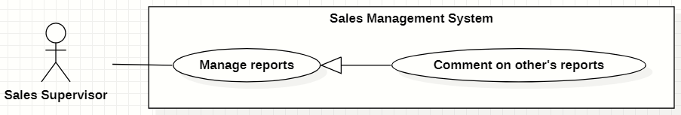

*Figure 49. <<Sales Supervisor>> Comment on Salesmen’s reports*

|  |  |  |  |  |  |
| --- | --- | --- | --- | --- | --- |
| ID and Name: | **UC-42 Comment on Salesmen’s reports** | | | | |
| Created By: | GiaNH | | Date Created: | | 12/02/2021 |
| Primary Actor: | Sales Supervisor, Sales Manager | | Secondary Actors: | | N/A |
| Description: | This use case allows the user to comment on Salesmen’s Reports. | | | | |
| Trigger: | The user clicks on the “Comment” command on the menu options at the end of row in table list of reports. | | | | |
| Preconditions: | PRE-1. The user has been logged into the system with role Sales Supervisor or Sales Manager.  PRE-2. The user is on the “Reports” screen. | | | | |
| Post-conditions: | POST-1. The comment is added on Salesmen’s reports. | | | | |
| Normal Flow: | **Step** | **Actor Action** | | **System Response** | |
| 1 | The user clicks on the “Comment” command on the menu options at the end of row in table list of reports.  [Alternative 1] | | The system displays “Comment on Report” dialog with the following information.   * “School Year”: text. * “Date”: text. * “School Name”: text. * “PIC”: image (avatar) and text. * “Purpose”: text. * “Result”: text. * “Description”: text. * “Positivity”: text. * “Difficulty”: text. * “Future plan”: text. * “Supervisor comment”: input text field, required. * “Cancel”: button. * “Save”: button. | |
| 2 | The user inputs his/her comment into the text field. | |  | |
|  | 3 | The user selects “Save” button.  [Exception 1] | | The system updates this report in the database with the new comment and closes the “Comment on Report” dialog .  [Exception 2] | |
| Alternative Flows: | **Step** | **Actor Action** | | **System Response** | |
| 1 | On the “Reports” screen, at the end of each row in the table, the user clicks on action icon button, then selects “View detail” command on the menu options. | | The system displays “Report’s details” view, the report’s information is displayed as a form.   * “School Year”: text. * “Date”: text. * “School Name”: text. * “PIC”: image (avatar) and text. * “Purpose”: text. * “Result”: input text field, read only. * “Description”: input text field, read only. * “Positivity”: input text field, read only. * “Difficulty”: input text field, read only. * “Future plan”: input text field, read only. * “Supervisor comment”: input text field. * “Save”: button, only active when the form is dirty. | |
| 2 | The user inputs his/her comment into the text field. | |  | |
| 3 | The user selects “Save” button.  [Exception 3]  [Exception 4] | | The system updates this report in the database with the new comment and shows the sucessful message “Updated Successfully”.  [Exception 2] | |
| Exceptions: | **No** | **Cause** | | **System Response** | |
| 1 | The user clicks on “Cancel” button. | | The system closes the “Comment on Report” dialog and returns to the “Reports” screen. | |
| 2 | The user’s device does not connect to the Internet or the server has internal error. | | The system shows the error message: “Connection Failed or Internal Error”. | |
| 3 | The user clicks on back button to go to “Reports” screen without edit anything in the form. | | The system discards all changes in the form and do not update anything to the database. | |
| 4 | The user eidts in the form’s fields but does not clicks on “Save” button before going back to “Reports” screen. | | The system discards all changes in the form and do not update anything to the database. | |
| Priority: | High | | | | |
| Frequency of Use: | Usually | | | | |
| Business Rules: | * BR-25, BR-26, BR-27, BR-29 * The user is not allowed to comment on his/her own reports. * The user shall comment on reports of other Sales Managers or Sales Supervisors. | | | | |
| Other Information: | N/A | | | | |
| Assumptions: | N/A | | | | |

*Table 45. <<Sales Supervisor>> Comment on Salesmen’s reports*

### 2.7 <<Sales Manager>> Overview Use Case

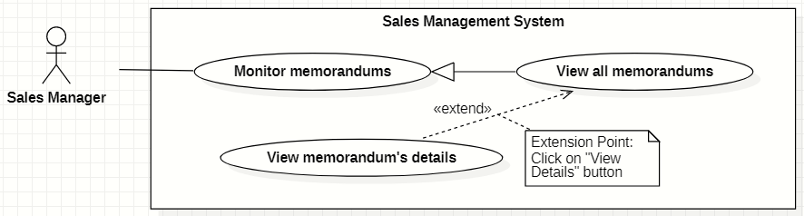

*Figure 50. <<Sales Manager>> Overview Use Case*

#### View all memorandums

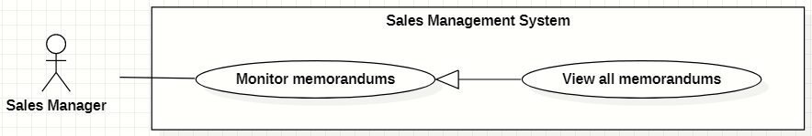

*Figure 51. <<Sales Manager>> View all memorandums*

|  |  |  |  |  |  |  |
| --- | --- | --- | --- | --- | --- | --- |
| ID and Name: | **UC-43 View all memorandums** | | | | | |
| Created By: | HaPTN | | | Date Created: | | 12/04/2021 |
| Primary Actor: | Sales Manager | | | Secondary Actors: | | N/A |
| Description: | This use case allows the user to view all memorandums of all target schools. | | | | | |
| Trigger: | The user selects tab “Memorandums” in “Target School’s details” screen. | | | | | |
| Preconditions: | PRE-1. The user has been logged into the system with role Sales Manager.  PRE-2. The user is on the tab “Memorandums” in “Target School’s details” screen. | | | | | |
| Post-conditions: | POST-1. Memorandum’s list is displayed as the table in “Memorandums” screen. | | | | | |
| Normal Flow: | **Step** | | **Actor Action** | | **System Response** | |
| 1 | | The user selects tab “Memorandums” in “Target School’s details” screen. | | The system displays “Memorandums” screen, memorandum’s list is displayed as the table.   * “ID”: text. * “Target Schools”: text. * “Duration”: text. * “Service”: text. * “Revenue Criteria”: text. * “Note”: text.   [Exception 1] | |
| Alternative Flows: | N/A | | | | | |
| Exceptions: | **No** | **Cause** | | | **System Response** | |
| 1 | No stored memorandums data in the system. | | | The system displays “No records found” line on the table. | |
| 2 | The user’s device does not connect to the Internet or the server has internal error. | | | The system shows the error message: “Connection Failed or Internal Error”. | |
| Priority: | High | | | | | |
| Frequency of Use: | Usually | | | | | |
| Business Rules: | BR-31, BR-34 | | | | | |
| Other Information: | N/A | | | | | |
| Assumptions: | N/A | | | | | |

*Table 46. <<Sales Manager>> View all memorandums*

## 3. Functional Requirements

### 3.1 System Functional Overview

#### Screen Flow

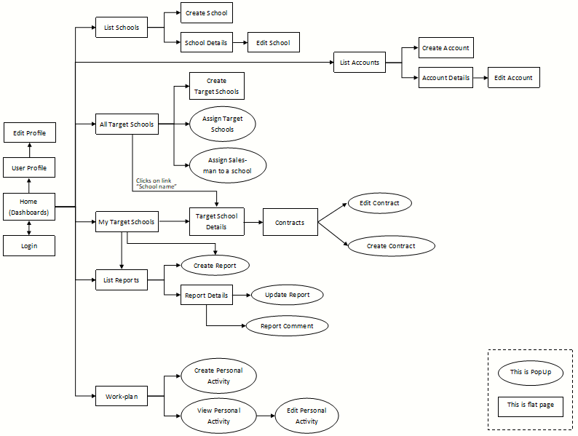

*Figure 52. Screen Flow*

#### Screen Details

|  |  |  |  |
| --- | --- | --- | --- |
| **#** | **Feature** | **Screen** | **Description** |
| 1 | Login | Login |  |
| 2 |  | Home (Dashboards) |  |
| 3 | View Profile | User Profile |  |
| 4 | Edit Profile | Edit Profile |  |
| 5 | * View list of schools * Search schools | List Schools |  |
| 6 | Create new schools | Create School |  |
| 7 | View school’s details | School Details |  |
| 8 | Edit school’s information | Edit School |  |
| 9 | * View list of accounts * Search accounts | List Accounts |  |
| 10 | Create new accounts | Create Account |  |
| 11 | View account’s details | Account Details |  |
| 12 | Edit account’s information | Edit Account |  |
| 13 | View list of all target schools | All Target Schools |  |
| 14 | Create target schools | Create Target Schools |  |
| 15 | Assign Salesmen to target schools | Assign Target Schools |  |
| 16 | Assign Salesmen to target schools | Assign Salesman to a school |  |
| 17 | * View list of assigned target schools * Search assigned target schools | My Target Schools |  |
| 18 | View target school’s details | Target Schools Details |  |
| 19 | Edit school’s information | Edit Target School Info |  |
| 20 | * View all reports * Search reports | List Reports |  |
| 21 | Create reports | Create Report |  |
| 22 | View report’s details | Report Details |  |
| 23 | Update reports | Update Report |  |
| 24 | Comment on Salesmen’s reports | Report Comment |  |
| 25 | * View my memorandums * View all memorandums | Memorandums |  |
| 26 | * View Memorandum’s details * Edit my memorandums | Edit Memorandums |  |
| 27 | View Workplan | Workplan |  |
| 28 | Create Personal Activities | Create Personal Activities |  |
| 29 | View Personal Activity’s details | View Personal Activity |  |
| 30 | Edit Personal Activities | Edit Personal Activity |  |

*Table 47. Screen Details*

#### Screen Authorization

|  |  |  |  |  |
| --- | --- | --- | --- | --- |
| **Screen** | **Salesman** | **Sales Supervisor** | **Sales Manager** | **Admin** |
| Login |  |  |  |  |
| Login | X | X | X | X |
| Dashboard | X | X | X |  |
| View Profile | X | X | X | X |
| Edit Profile | X | X | X | X |
| List Schools |  |  |  |  |
| View all schools |  | X | X | X |
| View school’s details |  | X | X | X |
| Create School |  |  |  | X |
| Edit School | X | X | X | X |
| List Accounts |  |  |  | X |
| Create Account |  |  |  | X |
| Account Details |  |  |  | X |
| Edit Account |  |  |  | X |
| All Target Schools | X | X | X |  |
| Create Target Schools |  | X | X |  |
| Assign Target Schools |  | X | X |  |
| Assign Salesman to a school |  | X | X |  |
| My Target Schools | X | X | X |  |
| Target Schools Details | X | X | X |  |
| Edit Target School Info | X | X | X |  |
| List Reports | X | X | X |  |
| Create Report | X | X | X |  |
| Report Details | X | X | X |  |
| Update Report |  | X | X |  |
| Report Comment |  | X | X |  |
| Memorandums | X | X | X |  |
| Edit Memorandums | X | X | X |  |
| Workplan | X | X | X |  |
| Create Personal Activities | X | X | X |  |
| View Personal Activity | X | X | X |  |
| Edit Personal Activity | X | X | X |  |

*Table 48. Screen Authorization*

#### Non-Screen Functions

|  |  |  |  |
| --- | --- | --- | --- |
| **#** | **Feature** | **System Function** | **Description** |
| 1 | Forget password | Send email | An email is sent to user’s email to provide a verification code for resetting the forgotten password. |
| 2 | Create new account | Send email | After Admin creating a new account, an email is automatically sent to the user’s email to provide password. |

*Table 49. Non-Screen Functions*

#### Entity Relationship Diagram

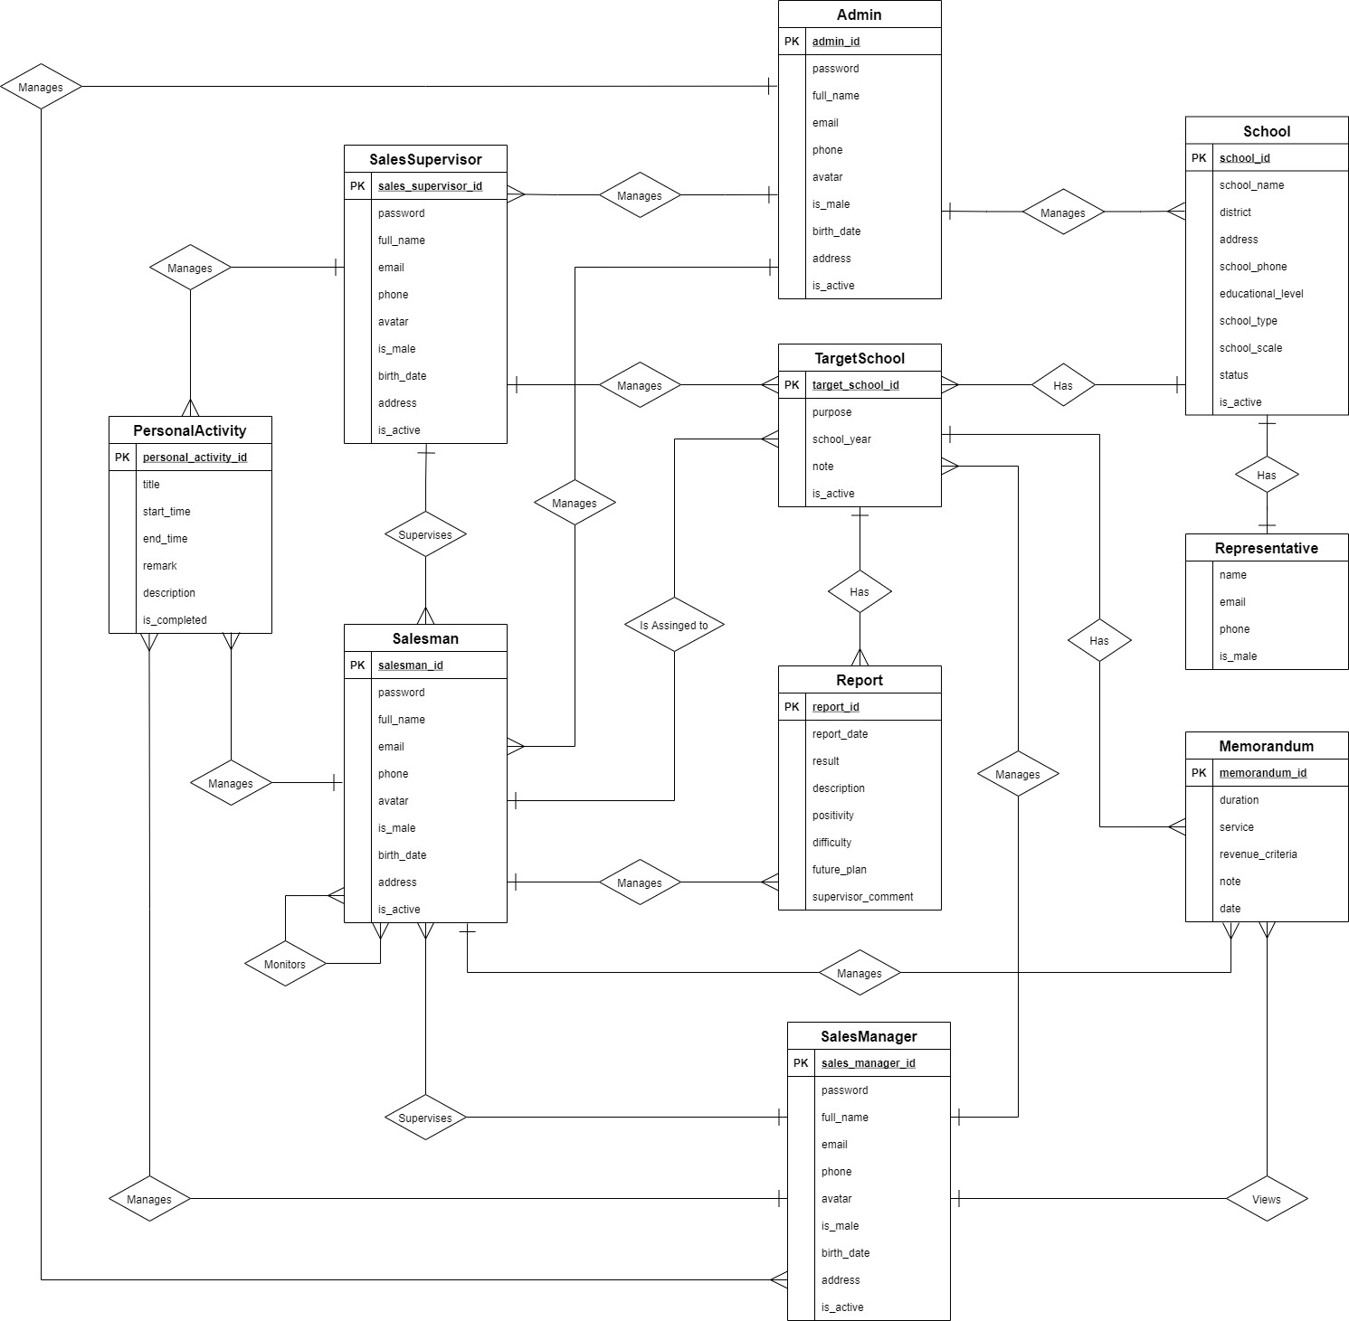

*Figure 53. Entity Relationship Diagram*

**Entities List**

|  |  |  |
| --- | --- | --- |
| **#** | **Entity** | **Description** |
| 1 | Admin | The Admin is an entity presenting a person who manages accounts and whole schools data of sale department.  Containing information of admin (id, password, full name, phone, email, avatar, address, birthday, isMale, isActive). |
| 2 | Salesman | The Salesman is an entity presenting a person who goes to work with the assigned target schools.  Containing information of Salesman (id, password, full name, phone, email, avatar, address, birthday, isMale, isActive). |
| 3 | Sales Manager | The Sales Manager is an entity presenting a person who manages and assigns the Target Schools to the Salesmen.  Containing information of Sales Manager (id, password, full name, phone, email, avatar, address, birthday, isMale, isActive). |
| 4 | Sales Supervisor | The Sales Supervisor is an entity presenting a person who manages, assigns the Target Schools to the Salesmen and also have right to view all memorandums of all target schools.  Containing information of Sales Manager (id, password, full name, phone, email, avatar, address, birthday, isMale, isActive). |
| 5 | School | The School is an entity presenting the school that was collected information and was select to become the target.  Contain information of School (id, name, district, address, phone, scale, type, educational level, status, isActive). |
| 6 | Target School | The Target School is an entity presenting the target that Sales Manager creates base on Schools list and assigns to Salesmen.  Containing information of School (id, purpose, school year, note, isActive). |
| 7 | Report | The Report is an entity presenting the report that Salesmen must submits to Sales Manager.  Containing the report information (id, date, result, description, positivity, difficulty, futurePlan, supervisorComment). |
| 8 | Personal Activity | The Personal Activity is an entity presenting an activity that Salesmen or Sales Managers create in work-plan and execute based on that.  Containing the Personal Activity information (id, title, startTime, endTime, remark, description, isCompleted). |
| 9 | Representative | The Representative is an entity presenting a person who is the representative for the school to contact.  Containing information of Representative (full name, isMale, email, phone). |
| 10 | Memorandum | The Memorandum is an entity presenting a memorandum between a target school and Major Education.  Containing information of Memorandum (id, duration, service, revenueCriteria, note, date). |

*Table 52. Entities List*

## 4. Non-Functional Requirements

### 4.1 External Interfaces

UI-1: The user interfaces in general should be consistent, simple, clear, intuitive, and reminiscent.

* Some design principles will be taken into consideration: <https://material.io/design/introduction>

UI-2: The user interfaces for the software shall be compatible with: Chrome (version 52 or above), Firefox (version 51 or above), Safari (version 10 or above) browser.

UI-3: The user interfaces should be responsive on multiple screen devices: Laptop, Tablet, and Mobile.

UI-4: The user interfaces should be clear and intuitive message for the users when there is a warning or an error.

UI-5: The user interfaces should ask the users to confirm the action when having major operating actions.

#### Software Interfaces

SI-1: This web application works with: Chrome (version 52 or above), Firefox (version 51 or above), Edge (version 14 or above), Safari (version 10 or above), or Opera (version 38 or above) browser.

#### Hardware Interfaces

HI-1: Since this system is a web application, which it shall work on Laptop, Tablet and Mobile.

HI-2: The system must run over the Internet; all the hardware shall require connect to the Internet.

#### Communications Interfaces

CI-1: The system shall communicate through HTTP protocol over the Internet.

### 4.2 Quality Attributes

#### Usability

- The system is designed simple, and intuitive which the users can easily manage their work.

- The default system language is English.

- The system shall take two hours of training for the users to familiar with usage.

#### Availability

- The system is available 24/7.

#### Security

- The system demands unauthorized users to log in for using the system.

- Each authentic user has a different role and scope for accessing a set of system functions.

- The password field must be obscured with special characters representing typed characters.

- The active session time for this system is two hours, after that the user shall be demanded to log in again.

#### Maintainability

- The source code should be based on a unified convention coding so that developers can easily manage.

- The system is divided into separate components and modules which giving the ability to update or scale up the system.

## 5. Other Requirements

### 5.1 Appendix1 - Messages List

|  |  |  |  |  |
| --- | --- | --- | --- | --- |
| **#** | **Message code** | **Message Type** | **Content** | **Content** |
| 1 | MSG01 | In red, above the text box | Invalid username or password | *Wrong format or invalid entry when user logs in.* |
| 2 | MSG02 | In red, above the text box | Wrong username or password | *Wrong username or password when user logs in.* |
| 3 | MSG03 | In red, under the text box | Invalid username or email | *Wrong format or invalid entry when user resets forgotten password.* |
| 4 | MSG04 | In red, under the text box | Wrong username or email | *Wrong username or password when user resets forgotten password.* |
| 5 | MSG05 | In red, above the text box | Invalid password | *Wrong current password when user changes password.* |
| 6 | MSG06 | In red, under the text box | Incorrect entry | *Wrong format or invalid entry when user updates something.* |
| 7 | MSG07 | Toast message, green | Password has been reset successfully | *Reset forgotten password successfully.* |
| 8 | MSG08 | Toast message, green | Updated Successfully | *Update something successfully.* |
| 9 | MSG09 | Toast message, red | Update Unsuccessfully | *Update something failed.* |
| 10 | MSG10 | Toast message, green | Create Successfully | *Create something successfully.* |
| 11 | MSG11 | In line, italic, gray | No records found | *Table does not have data to show.* |
| 12 | MSG12 | In line, red | Connection Failed or Internal Error | *Trouble with the Internet connection.* |
| 13 | MSG13 | Dialog | The school *[…school name]* is assigned already. If you want to assign to a new PIC, you need to unassign before assigning again. | *The user ticks on the target schools which have already been assigned.* |
| 14 | MSG14 | In line, red | Please choose the right file format. | *When the user import a file to the system.* |

*Table 53. Appendix1 - Messages List*

1. “MOU (*Memorandum of understanding)”* means “a document that describes the broad outlines of an agreement that two or more parties have reached”.

   Kenton, W., 2021. *Memorandum of Understanding (MOU): What You Need to Know*. [online] Investopedia. Available at: <https://www.investopedia.com/terms/m/mou.asp>.